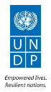
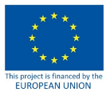

Contract number: ENPI/2014/354-587

Project Title: Support to Confidence Building Measures Starting date: 15 March 2015
Report end date: 31 December 2015
Implementing agency: UNDP Moldova
Country: Republic of Moldova

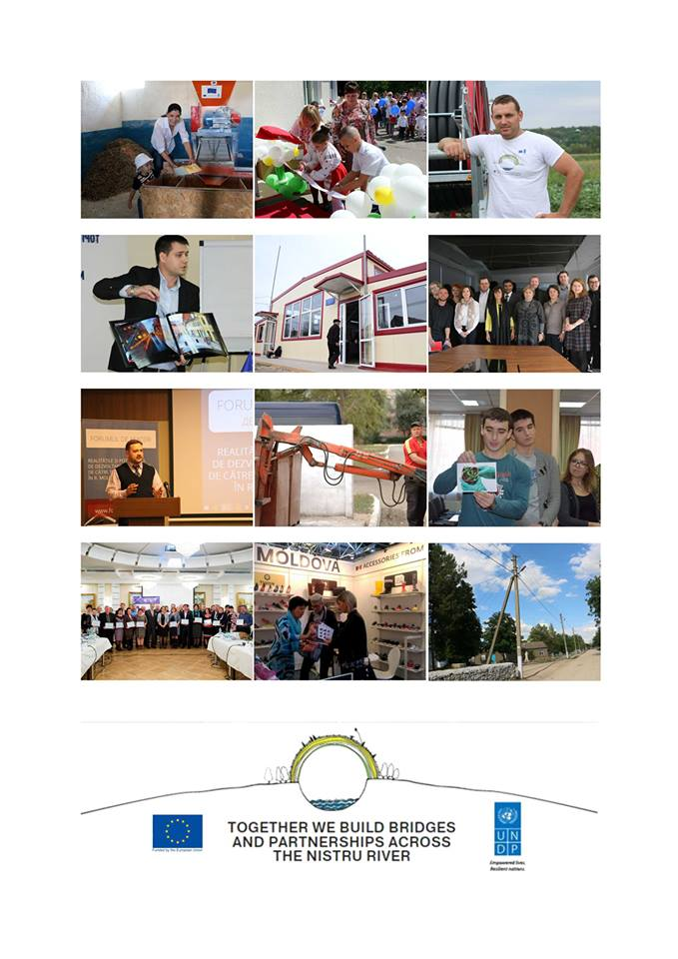

Table of Contents
I. SUMMARY 4
II. CONTEXT 6
III. PROGRESS UPDATE 7
3.1 Business Development and Employment Opportunities 8
3.2 Empowered Communities and Infrastructure Support 8
IV. KEY RESULTS 9
4.1 Business Development and Employment Opportunities 9
4.2 Empowered Communities and Infrastructure Support 11
V. DIFFICULTIES ENCOUNTERED AND MEASURES UNDERTAKEN TO OVERCOME PROBLEMS 13
5.1 Issues and Challenges 13
5.2 Risk Log 14
VI. IMPLEMENTATION ARRANGEMENTS AND CHANGES 15
VII. MEDIA COVERAGE /VISIBILITY 15
VIII. FUTURE PLANS 15
IX. ANNEXES 17
Annex 1: Key Results measured in accordance with the Description of Action Results and Resources Framework 18
Annex 2: List of Business Development and Employment Opportunities projects 22
2.1. Supporting Business-to-Business Activity 22
2.2. Stimulating Business Development Services 26
2.3. Promoting a Culture of Entrepreneurship and Support Young Entrepreneurs 27
Annex 3: List of Community Infrastructure Projects 30
Sub-Project 1: Overall renovation of the Rascov Community Centre 30
Sub-Project 2: Overall repair of the Child and Youth Creativity Hall in the town of Dubasari 30
Sub-Project 3: Replacement of heating system and doors, construction of lavatories, renovation of the sports and conference halls (General education school/kinder garden no. 2) in Nezavertailovka 31
Sub-Project 4: Renovation of School no. 2 in Chitcani 31
Sub-Project 5: Replacement of windows, repair of roof and cafeteria/festivity hall for the school in Glinoe 32
Sub-Project 6: Renovation of the town polyclinic in Dnestrovsk 32
Sub-Project 7: Renovation of the centre for victims of human trafficking in Tiraspol 33
Sub-Project 8: Improvement of educational, socio-cultural and sport services provided by the complex in Varnita (Anenii Noi district) 33
Sub-Project 9: Renovation of the Community centre in Corjova (Criuleni district) 33
Sub-Project 10: Modernization of the regional cultural centre from Slobozia-Dusca (Criuleni district) 34
Sub-Project 11: Construction and equipment of the Office of Family Physicians from Hagimus (Causeni district) 34
Sub-Project 12: Renovation of the infectious diseases section of the Rezina district hospital 35
Sub-Project 13: Construction of and equipment provision for a sports field and playground at the Latin-script Theoretic Lyceum Evrika from Ribnita town 35
Sub-Project 14: Capital renovation of the bridge on Drumul Tirgului street from Hirbovat (Anenii Noi district) 36
Sub-Project 15: Renovation of the sports complex facility in Serpeni village (Anenii Noi district) 36
Sub-Project 16: Renovation of the Molovata village community centre (Dubasari district) 37
Sub-Project 17: Thermal insulation, replacement of windows and renovation of the stadium for the Cirnateni village lyceum (Causeni district) 37
Sub-Project 18: Renovation of the Dorotcaia village Community centre (Dubasari district) 38
Sub-Project 19: Reconstruction of the village sewerage system (Speia, Anenii Noi district) 38
Sub-Project 20: Renovation of the Office of Family Physicians and establishment of outpatient treatment section in Gura Bicului (Anenii Noi district) 38
Sub-project 21: Professional Consulting Services provided by CONTACT Centre 39
Sub-project 22: Professional Consulting Services provided by the INTERACTION NGO 39
Sub-Project 23: Training on interpreting and using gender-related data for mixed data producer-user groups 40
Sub-Project 24: Study on data users’ capacities on both banks of the Nistru River in targeted communities 41
Annex 4: Communication and Visibility Report 42

SUMMARY
Title of the Programme: Increased opportunities and better living conditions across the Nistru/Dniestr River
Location: Republic of Moldova and its Transnistria region
Programme budget: €10 mil., provided by the European Union
Total duration | 36 months
Objectives | The overall objective of the programme is to contribute to an environment of trust and cooperation across the Nistru/Dniestr River generating new perspectives on shared interests and a shared future by people from both banks of the river while responding to their pressing development needs.  Specific objectives (outputs):  Output 1 (Business development and employment opportunities):  - Increased cross-river cooperation of economic actors leading to improved employment opportunities and livelihoods across the Nistru/Dniestr River.  Output 2 (Empowered communities and infrastructure support):  - Empowered local communities and actors from both sides to participate in collaborative projects addressing pressing development needs and improving critical community infrastructure.  The programme represents a framework for engaging in development interventions across the security zone on both sides of the Nistru/Dniestr River, in line with agreements reached in the 5+2 negotiation process. As such, it is comprised of a series of activities that will strengthen, regularize and intensify interaction between otherwise divided societies, aiming to establish this interaction as a norm.  It looks to deal strategically with barriers to cooperation experienced by all development cooperation actors working in Transnistria region of Moldova by building the trust towards such actions and broadening opportunities for engagement for a wide range of actors.  Additionally, it will provide support for improving critical community infrastructure, in line with agreements reached during the working groups and broader negotiation process.
Partner(s) | The Government of Moldova, the Bureau for Reintegration, de-facto local authorities from the Transnistrian region, business associations from Chisinau and Tiraspol (including Chambers of Commerce on both banks), regional/municipal authorities, community-based organizations, international, national and local NGOs active in the Transnistrian region and the security zone.
Target group(s) | - Economic actors including SMEs, Chambers of Commerce, business associations, etc. from both banks of the Nistru/Dniestr River;  - Communities and community-based organizations in the Transnistria region and the security zone;  - Statistics specialists on both banks;  - Vulnerable women and men in the target region.
Final beneficiaries | Citizens in the Republic of Moldova including the Transnistria region
Estimated results | For Output 1: Business development and employment opportunities  - At least 50 cross-river business exchanges and partnerships promoted between businesses and business associations leading to common understanding of opportunities, barriers and technical standards in the field of business development;  - At least 200 SMEs (including women led SMEs) involved in joint activities and received business support services contributing to increased professionalization and higher business standards on the left bank;  - New opportunities for business cooperation across the river and at least 150 new jobs and 5,000 new livelihoods for women and men;  - Consolidated local consultancy market providing improved services fostering local capacities to use the benefits provided by the DCFTA in terms of access to the EU market with at least 20 business consultants trained and/or certified;  - Improved culture of entrepreneurship and greater access to information and funding leads to the creation of 30 new businesses, integrated into existing cross-river platforms.  For Output 2: Empowered communities and infrastructure support  - At least 60 local actors have increased capacities for sustainable development and ensuring access of most vulnerable to public services by empowering communities;  - At least 30 social infrastructure projects supported in the security zone (on both banks of the river);  - About 100,000 women and men directly benefited from the implementation of the programme;  - Increased interaction between statisticians from Chisinau and Tiraspol leading to better compliancy with international standards (in at least 5 statistical areas) as a result of at least 5 learning activities targeting 30 professionals;  - Increased level of cooperation and trust across the river.
Main activities | - Business Development and Employment Opportunities  Projects which promote the common interests of business actors from both banks in the context of EU integration will be implemented. This component will address comprehensively some of the key constraints faced by business and will focus heavily on creating sustainable cross-river business partnerships. Business to business interaction will be sustained through the facilitation of cooperation between business associations, supporting business cooperation networks, and building local capacities for export. Continuing the successful experience of previous phases of the programme, the business development services market will be further consolidated by bolstering the capacities of local private actors, business associations and consultants to provide certified services enabling the local business to capitalize on the existing opportunities, including those offered by the DCFTA. Additionally, a culture of entrepreneurship will be promoted energetically in the region, focussed mainly on enabling youth on both banks to become successful entrepreneurs.  Partnerships with civil society and businesses will be the main vehicle of the component implementation. Aiming to increase the cross-river cooperation, this component will also focus on contributing to enhance employment opportunities, and particularly supporting the creation of new jobs and livelihoods for women and men across the river.  - Empowered communities and infrastructure support  Support will be provided for projects oriented towards facilitation of the settlement and post-settlement period. Assistance could take various forms and cover areas like transport, infrastructure, environment, energy and many others. Infrastructure projects from both banks of the Nistru/Dniestr river will be supported in a balanced manner as decided by the programme board.  Partnership with civil society organizations will be sought to enable and empower people from both banks to jointly participate in tackling community development needs, particularly the rehabilitation of social institutions and basic infrastructure, ranging from renovation of schools, kindergartens, or health centres. Additionally, the project will contribute to the capacity development of the beneficiary communities, and create/strengthen communication channels across the river.  Other activities would involve supporting the development of skills and knowledge of statisticians on both banks to produce qualitative and reliable statistical data and foster dialogue between experts in the field on both banks.

CONTEXT
In 2015, the secessionist eastern region of Transnistria was affected by an unprecedented economic crisis and political tectonic shifts that point to risks of instability in the short to mid-term future. Attempts to revive the 5+2 official negotiation process and Track 2 interactions of sectorial working groups, ended in little progress. The effects of the conflict in nearby Ukraine, which plays, along with Russia, a key role in the talks, were felt beyond the political/security realm, affecting transit trade and imports. Significantly devaluated currencies in Moldova, Russia and Ukraine, along with Tiraspol’s decision to keep the local de facto currency pegged to the US dollar led to plummeting competitiveness of local exports and a drop in internal consumption, exacerbating negative economic trends, and producing hyperinflation risks for 2016. The region’s 2015 GDP was expected to contract by 10-12%, households’ revenue by 30% and consumption by 21-22%.
Despite the de facto government’s decision to cut pensions (in 2015, the number of pensioners in the region became larger than of those employed) and salaries by 30%, a budgetary crisis is looming, unless the TN tax system is reformed to introduce VAT, thus allowing exports and SMEs to grow. With large enterprises closing, the SMEs remained resilient and have the most potential to bring back growth. EU’s decision to allow Transnistria-based companies to continue trading within the DCFTA with Moldova at zero tariffs in 2016 brings more opportunities to local exporters, but is contingent on the willingness of the de facto administration to reform. As the October local elections showed, the near future might be characterized by political instability as the legislative in Tiraspol has now a significant majority of the party opposing de facto president Shevchuk.
The overall negative context took its toll on the situation on the ground, with the fourth phase of the SCBM Project launched in March 2015. As barriers to cross-river interaction multiplied, under the influence of the external factors and continued disagreement at the political level, the implementation of joint projects that would bring together people and communities from both banks became increasingly difficult. Despite a growing interest of people from both banks to cooperate and solve problems together, the labour intensiveness of project implementation also increased, with additional efforts needed to overcome obstacles to confidence building activities. Careful management of relations with officials across the conflict divide, and adaptation to changing conflict conditions, were crucial to ensuring their success.
In 2015, the validity of the SCBM Programme’s rationale was confirmed, as important results have been achieved already on the ground, continuing the success of its previous three phases. An EU-commissioned impact evaluation in September concluded that “the chosen pathways led to the desired outcome by weakening the dividers and increasing society’s resilience to mounting negative pressures; by strengthening cooperative ties, shared developmental goals and demonstrating the benefits of cooperation in practice; and in preserving commonalities in the identity domain”.
At the same time, while the focus on non-political areas, involving both sides in joint work to solve common problems, and encouraging people-to-people contacts, continued to prove successful, the grim economic and political outlook signals the need for prudency and realistic planning for the future. Maintaining an inclusive, consensual, win-win approach to advancing development projects that have a tangible beneficial effect on both sides, will be crucial in enlarging the local constituencies in favour of cross-river cooperation and, ultimately, in strengthening confidence between the people on both banks of the Nistru.

PROGRESS UPDATE
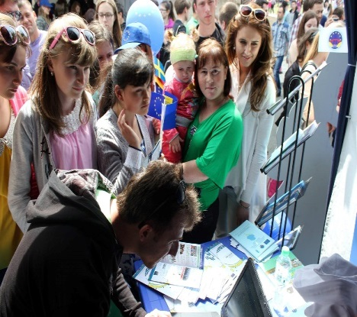
Despite a highly challenging year and overall sensitive regional context, the Programme implementation team managed to successfully launch the new phase and achieve impressive results already, even exceeding some of the targets initially set in the Description of Action. The experience acquired and lessons learnt during the implementation of previous phases of SCBM Programme were of particular help, as were the recommendations provided as a result of the EU Impact Evaluation mission carried out in September 2015.
Europe Days, Soroca, May 2015
As SCBM IV commenced in March 2015, activities were started efficiently and fast. Notwithstanding difficulties caused by right-bank local elections in June, and the November elections on the left-bank, the team managed to organize efficiently competitions, which were met with great interest, with more than 135 project proposals from both banks received. At least 50 field visits were organized to assess the technical condition of the objects proposed for reconstruction, allowing the members of the Selection Committee to decide on the best proposals based on up-to-date information. Despite impediments, the number of social infrastructure objects selected for implementation exceeded the expected targets for 2015 – 20 versus 16 objects. Reconstruction works and technical documentation drafting are on track to be completed in 2016 and 2017 (detailed information about each sub-project in Annex 3).
Within the Business Development and Employment Opportunities component, activities successfully kicked off in all three main sub-components --- Support Business-to-Business Activity, Stimulate Business Development Services (BDS), and Promote a Culture of Entrepreneurship and Support to Young Entrepreneurs. The economic downturn and tensions related to external trade issues (DCFTA, transit via Ukraine) increased the sensitiveness for activities in the field; however, the project implementation team managed to successfully attain all targets for the year and has set a solid foundation to reach the goals of the Component (for detailed information about each sub-project see Annex 2). High risks still need to be looked out for, related to an overall externally-driven worsening economic situation on both banks of the Nistru.
As the project unfolded, the team has carefully managed relations and partnerships built in Moldova and its Transnistrian region to ensure smooth implementation of all areas. Close coordination, knowledge sharing and joint work was ensured between different UN agencies to share knowledge and expertise. Furthermore, efforts were made to mainstream gender across all components, aiming to make positive and transformative contribution to the achievement of gender equality and women’s empowerment.
During the first year, the Programme has fully and firmly established itself on the ground, and has created solid prerequisites for successful work during the remaining period.
Key results to date: | - 10 cross-river business exchanges and partnerships supported;  - at least 60 enterprises from both banks benefitted from business support services;  - 31 beginner entrepreneurs on both banks supported through the Grants for Youth Programme are receiving a 14 month consultancy/coaching assistance, generating 160 new jobs;  - at least 2,000 women and men benefitted from improved livelihoods;  - 20 community infrastructure projects under implementation, ;  - more than 60,000 direct beneficiaries of the selected social infrastructure projects;  - Over 30 local actors have improved capacities to identify relevant confidence building project ideas and elaborate social infrastructure project proposals;  - 14 statisticians and relevant specialists from both banks of the Nistru River have improved capacities and skills during a training on gender-related statistical data.
During the reporting period, two Programme Board meetings have been conducted (14 April and 22 September 2015), where the new phase of EU-UNDP SCBM Programme was presented, quarterly reports and funding of 13 infrastructure projects proposals submitted by the Selection Committee have been approved. On 30 November 2015, the Programme Board additionally approved for funding 7 infrastructure projects via e-mail. Minutes of the Board Meetings are presented in Annex 4 and provide more information on the Programme implementation process.
Key developments per component are presented in more detail below:

Business Development and Employment Opportunities
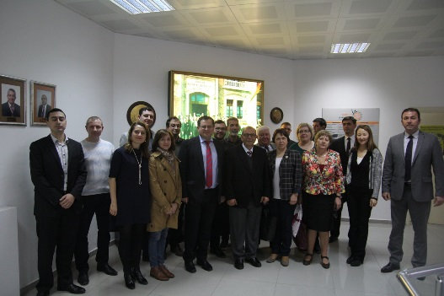
On the backdrop of negative economic trends on both sides of the Nistru, the Programme managed to help address some of the key constraints faced by businesses and to support sustainable partnerships between business communities from both banks as well as the creation of new jobs and improved livelihoods for women and men across the river. The operational targets set for 2015 have been fulfilled in all intervention areas. Activities implemented during the reported period aimed to link-up and develop cooperation between existing business associations through joint participation at Business forums, study visits, joint research, participation at fairs and exhibitions, collaborative platforms between entrepreneurs, etc., with around 10 cross-river business exchanges and partnerships supported. All in all, at least 60 enterprises from both banks benefitted from the project so far, being able to develop their business opportunities.
Study visit of Business Development Service providers from both banks to Cyprus, December, 2015
In 2015, negative economic trends and structural issues led to a shared scepticism among business communities on both banks, and a temporary reluctance to invest in consulting/BDS, reducing short-term perspectives for growth in this market. However, by focussing on developing the capacities of Business Associations, and working with BDS providers to improve their products and attractiveness, the SCBM Project is supporting a strong foundation for the future of this market, much needed to promote sustainable economic growth and exports. .
Following the positive results of the Creation of Job Opportunities through the Business Support for Youth (Grants for Youth) project within the SCBM III, a second phase was launched, with a view to encourage youth entrepreneurship on both banks of the river, create new jobs and strengthen entrepreneurial skills among young people. The project generated a high interest, with more than 300 applicants, 200 attendees of business plan writing courses. As a result, Grants of up to 13,500 euros were awarded to 31 young entrepreneurs from both banks, including 8 women, who have started new businesses that should create at least 150 jobs. Additionally, the entrepreneurs receive 14 months of coaching and consultancy to ensure sustainable results of their activities. Overall, more than 2,000 women and men from both banks of the Nistru River have improved livelihoods as a result of the projects implemented within this component.

Empowered Communities and Infrastructure Support
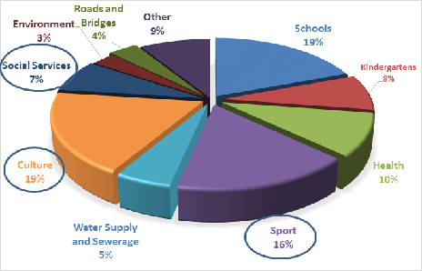
Activities implemented within this component were aiming to tap into the confidence building potential of the communities selected for the funding of social infrastructure objects. To ensure a tangible impact, the agreed approach was to focus on medium-sized infrastructural projects with an average budget of up to 150,000 EUR, targeting for 30 community infrastructure development projects.
Social infrastructure proposals main thematic areas
During the reporting period, the SCBM Programme successfully organized proposal competitions on both banks, and received 135 infrastructure project proposals. Following a thorough selection process, the Programme Board approved for funding 20 social infrastructure projects (13 projects on the right bank and 7 on the left bank of Nistru River) versus 16 targeted for 2015. These include: renovation of 5 schools, 5 cultural centres, 2 offices of family physicians, 2 health care institutions, 1 youth creativity hall, 1 sports centre, 1 community service centre, 1 centre for victims of human trafficking, reconstruction of 1 bridge and 1 sewerage system. The total number of people who will benefit from improved social infrastructure objects exceeds 64,700 people. A next competition to select the remaining social infrastructure projects is envisaged for the first half of 2016.
Based on lessons learned from previous SCBM phases and the conclusions of the Impact Evaluation, special attention was paid to building the capacities of the Local Public Administrations (LPA) on both banks to better assess their communities’ needs, as well as plan, implement, and ensure the sustainability of social infrastructure projects. Thus, a complex capacity development program has been initiated and is currently implemented by two consulting companies from each side of the Nistru River. LPAs from 27 communities on the right bank which previously had not benefitted from SCBM funding were assisted to identify relevant confidence building project ideas and submit their social infrastructure project proposals. Following the selection of social infrastructure projects, the consultants elaborated capacity gaps assessment reports and capacity development and confidence building action plans for 10 communities from the right bank and 4 from the left bank, including 4 community needs reports for the latter. Additionally, an expert has conducted a detailed review of 40 social infrastructure objects completed during 2012-2015 (SCBM III) focusing on the operationalization of the renovated objects and sustainable management ensured by the local authority in the post-implementation period. A set of recommendations on increasing the social impact, promoting cross-river cooperation and people-to-people interaction will be provided to SCBM Programme to be taken on-board during the implementation of social infrastructure projects within the current phase.
As regards the activities to support the development of skills and knowledge of statisticians on both banks of the Nistru River, 4 statisticians from the right bank and 10 relevant specialists from the left bank improved their skills on interpreting and using gender-related data and established contacts to be built on in the future. Two consultancy companies have been engaged in a cross-river partnership to undertake a baseline study assessing data users-producers’ capacities on both banks in targeted communities to provide recommendations on how to improve statisticians’ and data users-producers’ capacities.

KEY RESULTS
Key achievements during the implementation period, in relation to the performance indicators are:

Business Development and Employment Opportunities
Programme Estimated Result: At least 50 cross-river business exchanges and partnerships promoted between businesses and business associations; at least 200 SMEs (including women led SMEs) involved in joint activities and received business support services; new opportunities for business cooperation across the river and at least 150 new jobs and 5,000 new livelihoods for women and men; consolidated local consultancy market providing improved services fostering local capacities to use benefits provided by the DCFTA in terms of access to the EU market with at least 20 business consultants trained and/or certified; improved culture of entrepreneurship and greater access to information and funding leads to the creation of 30 new businesses, integrated into existing cross-river platforms.

2015 Targets and Key Results:
Target 1 - At least 10 cross-river business exchanges and partnerships promoted
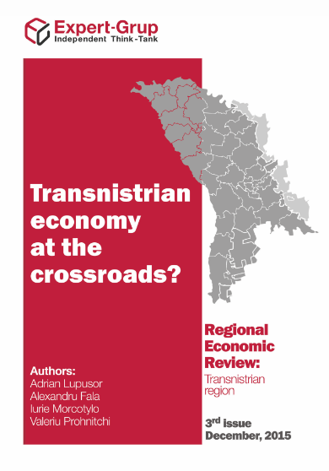
- Experts in the economic field from both banks have been involved in a project focussed on economic research and forecast – the Regional Economic review: Transnistrian Region – a year-long initiative studying the economic situation in the Transnistrian region based on publicly available data, and doing capacity building for evidence-based policy analysis and advocacy for representatives of CSOs/academia from the Transnistrian region;
- A one-day Business Forum in Chisinau brought together for the first time ever more than 120 young entrepreneurs from both banks, enabling them to discuss about common challenges and needs, learn about modern business methods, and establish lucrative contacts;
- A Memorandum of cooperation and a joint work plan for 2016 was signed between two agricultural business associations from both banks– Moldova Fruct and Dnestrovskii Frukt;
- A partnership between the Tiraspol Chamber of Commerce and the Business Consulting Institute, implementing synchronously the Grants for Youth initiative, has also resulted in the consolidation of a business platform for supporting collaboration between young entrepreneurs from both banks of the Nistru River, in process of being further developed: www.business-bridges.md;
- A strong partnership between 5 companies from both banks (2 from Transnistria) has been supported, in the framework of the Moldovan Association of Light Industry Producers (APIUS), including via their participation at a common stand at the largest shoes and accessories fair in the world, GDS, in Dusseldorf, Germany;
- More than 30 university students interested in entrepreneurship were enabled to work together to develop innovative solutions in promoting the culture of entrepreneurship during an Innovative Design Thinking Workshop, and establish contacts to be explored in the future;
- More than 20 representatives of the Business Development Services market on both banks were able to establish contacts, and develop ideas of possible future joint work, as well as learn from the experience of EU countries in this field during 2 study visits in Poland and Cyprus;
- During the study visit to Cyprus, Intereconomservice from Rybnita and the Rezina Business Incubator decided to establish a partnership in sharing expertise and learning about exporting opportunities, including via DCFTA;
- As a result of the focus group meetings and the visits organized within the study on the Business Development Services market needs, representatives of sector companies from both banks expressed the will to create a joint association of professional consultants that is on track to materialize in 2016.

Bottom line: at least 10 cross-river business exchanges and partnerships supported

Target 2: 40 enterprises from both banks benefitting from business support services (20% women led enterprises; 50% from Transnistrian region)
- 31 newly created enterprises via the Grants for Youth Programme (16 from the Transnistrian region, 18 led by women) are involved in a 14 month consultancy/coaching support program;
- 5 companies from both banks (including 2 from Transnistrian region) were supported to prepare for and participate at the largest shoes and accessories fair in the world, in Dusseldorf, Germany, with the help of the Moldovan association of Light Industry Producers (APIUS);
- 24 fruit producing companies from both banks (10 from the left bank) representing two agricultural business associations (Moldova Fruct and Dnestrovskii Frukt) benefitted from a training on how to prepare their orchards for winter. Also, the two associations signed a protocol of cooperation and a joint work plan for the year 2016 extending economic opportunities in the field of agriculture for these companies and their communities.

Bottom line: At least 60 enterprises from both banks (28 from TN) benefitted from business support services

Target 3: At least 40 new jobs additionally created, (at least 40% for women, at least 50% in Transnistrian region)
- More than 150 jobs are on track of being created (more than 40% for women, 78 in the Transnistria region,) by the 31 young entrepreneurs supported via the Grants for Youth Programme;

Bottom line: More than 150 jobs on track of being created (more than 40% for women, 78 in the Transnistria region)

Target 4: At least 1,000 women and men (50% women) benefiting from strengthened livelihoods
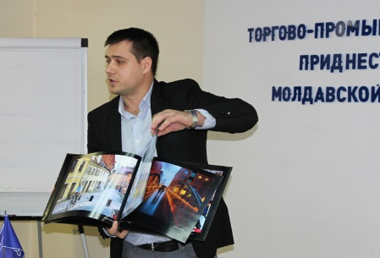
- More than 1,700 (of which at least 1,200 are women) employees of the companies supported to promote their exports at the fair in Dusseldorf, Germany, have received additional opportunities as their companies are extending their geography of exports;
- Over 500 men and women employed in the 24 fruit producing companies that developed a joint working plan and learned new methods on how to prepare their orchards for winter have access to improved livelihood opportunities;
- More than 200 attendees of the business plan writing courses within the Grants for Youth Programme, including the 31 grants beneficiaries, and more than 150 of their future employees ;
Young entrepreneur in Tiraspol presenting his business plan ogramme beneficiary
- Over 10 economic experts from the Transnistrian region developed their knowledge and capacities to promote evidence-based policy making;
- 23 representatives of companies providing Business Development Services from both banks (including 13 women) learned about best practices in providing BDS, had the opportunity to establish contacts in their industry, during 2 study visits (Poland, Cyprus), and were enabled to provide improved services of this type locally.

Bottom line: At least 2,000 women and men benefitted from access to opportunities for improved livelihoods

Target 5: Initial activities in view of consolidating local consultancy market providing improved services fostering local capacities to use the benefits provided by the DCFTA in terms of access to the EU market (partners identified and training programs set out)
- 23 representatives of companies providing Business Development Services from both banks (more than 50% women) got acquainted with best practices in providing BDS as a result of 2 study visits (Poland, Cyprus). The Rezina Business Incubator established contacts with a counterpart from the Transnistrian region (Intereconomservice, Ribnitsa) to undertake future joint projects and an agreement has been established to organise cross-river discussions to better understand DCFTA requirements for export and address the challenges faced in the Transnistrian region through EBA (European Business Association) implication;
- A needs assessment study currently carried out by a cross-river partnership is formulating the main needs of the local consultancy market and is developing a concrete set of recommendations, including training programs, potential partners, etc.

More details and a summary of each sub-project implemented in this component are presented in Annex 2.

Empowered Communities and Infrastructure Support
Programme Estimated Results: At least 60 local actors have increased capacities for sustainable development and ensuring access of most vulnerable to public services by empowering communities; at least 30 social infrastructure projects supported on both banks of the river; about 100,000 women and men directly benefited from the implementation of the programme; increased interaction between statisticians from Chisinau and Tiraspol leading to better compliancy with international standards (in at least 5 statistical areas) as a result of at least 5 learning activities targeting 30 professionals; increased level of cooperation and trust across the river.

2015 Targets and Key Results:

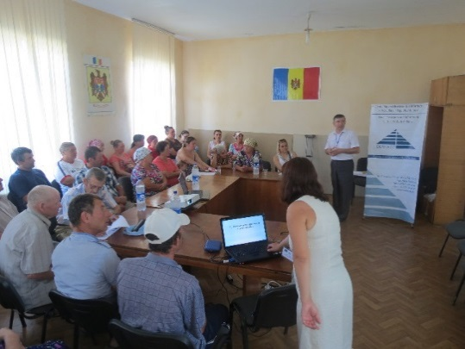
Target 1: Increased level of openness and trust toward development support received
Representatives of LPAs during capacity development exercises
- High interest in social infrastructure projects implementation from communities on both banks of the Nistru River. 95 communities, including 39 from the Transnistrian region, submitted 135 social infrastructure project proposals aimed at addressing community development needs in areas of education, culture, sport, health care, water supply and sewerage, social services, road infrastructure, etc.
- A one-day round table – Increased opportunities and better living conditions across the Nistru River was attended by representatives of communities from both banks in which social infrastructure projects will be implemented. The event provided an opportunity for networking, creating partnerships, communication, and identifying future joint CBM initiatives to increase the social impact, cross-river cooperation and people-to-people interaction.

Target 2: At least 20 local actors with improved capacity for implementing development projects
- Following two separate competitions, two consulting companies were selected: Contact Centre to conduct capacity development activities in communities from the right bank while NGO Interaction – on the left bank of the Nistru river;
- Experts of Contact Centre visited 27 eligible communities which previously have not benefitted from SCBM funding and elaborated needs assessment reports offering support to LPAs in identifying relevant confidence building project ideas and assisted them during the elaboration of social infrastructure project proposals for submission to SCBM Programme;
- Additionally, Contact experts elaborated capacity gaps assessment reports and capacity development and confidence building action plans for 10 communities from the right bank selected for the funding of social infrastructure objects;
- Interaction experts elaborated 4 community needs and capacity gaps assessment reports as well as capacity development and confidence building action plans for 4 communities from the left bank selected for the funding of social infrastructure object;
- A total of 5 field visits to target communities considered for Grant Agreement implementation scheme were organized and 4 capacity gaps assessment reports were completed.

Target 3: At least 16 social infrastructure projects initiated on both banks of the Nistru River (at least 50% in the Transnistrian region)
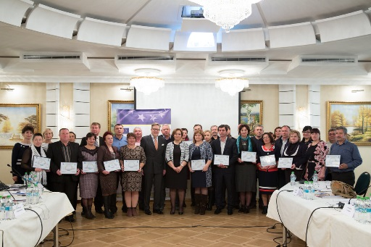
- Three competitions for the selection of social infrastructure projects carried out in 2015;
- A total of 135 project proposals submitted by 95 communities from both banks of the Nistru River examined by the Selection Committee and approved by the Programme Board;
- Over 50 field visits carried out by the Programme team to assess the technical condition of objects proposed for reconstruction;
- A total of 20 communities were selected for the funding of social infrastructure objects and further will benefit from extensive capacity development activities. 13 projects were selected for funding on the right bank and 7 on the left bank of Nistru River;
Certificates awarded to LPAs representatives, Chisinau, November 2015
- Reconstruction works initiated and technical documentation is prepared for 20 social infrastructure projects on both banks of the Nistru River;
- 17 projects will be implemented directly by SCBM Programme while 3 projects will receive grants to conduct reconstruction works.

Target 4: At least 10,000 women and men benefitting from improved services and small infrastructure, enjoying better access to basic community services
- Overall, 64,733 (women: 34,183 and men: 30,550) direct beneficiaries of improved services provided by social infrastructure objects;
- 2,965 people (2,044 women and 921 men) involved in participatory activities.

Target 5: At least 2 learning activities in at least 2 statistical areas implemented
- A training on interpreting and using gender-related statistical data for mixed data producer-user groups conducted for 14 statisticians and relevant specialists from both banks of the Nistru River;
- A study to assess data users-producers’ capacities on both banks of Nistru River was commissioned to a cross-river partnership between two consulting companies to provide recommendations on how to improve statistician’s and data users-producers’ capacities and skills.

Target 6: At least 75% of the total number of projects implemented with a quality rating of satisfactory overall or higher
- Reconstruction of 20 social infrastructure objects initiated in December 2015 and works are ongoing. To ensure high quality projects implementation, the construction companies have been contracted following an open international, highly competitive selection process;
- Additionally, two international experts have been contracted to supervise and ensure the quality of technical documentation and the selection process of companies responsible for reconstruction.
More details and a summary of each project are presented in Annex 3.

DIFFICULTIES ENCOUNTERED AND MEASURES UNDERTAKEN TO OVERCOME PROBLEMS

Issues and Challenges
Despite an initial declarations of acceptance by the de facto authorities, during talks with representatives of the EU Delegation and of the SCBM team, of the main directions of action and planned activities for the new phase, the practical implementation on almost each project needed additional work to secure an agreement and a go-ahead. Due to these circumstances, the launch of some projects took longer than initially planned, and required supplementary efforts on behalf of the implementation team.
For example, the Grants for Youth sub-project, a continuation of a previously successful initiative that received high praise from local authorities, has faced administrative difficulties in Tiraspol, that could make its implementation more difficult and put additional taxes/pressure on the local implementing partner, the Tiraspol Chamber of Commerce, and project beneficiaries. The SCBM team has, in close partnership with the EU delegation, addressed the issue via sustained dialogue with local officials, and the sub-project is continuing its work; however, risks still remain and careful management of the situation is needed.
In the case of infrastructure projects, difficulties were encountered with regards to the development needs assessment activities carried out on the left bank by partner NGOs, due the reluctance of local representatives to engage, compounded by the unfavourable and tensioned political context. In this situation, the SCBM team has spent a lot of time to explain that reconstruction works have to be carried out concomitantly and complementarily to capacity building support activities, including confidence-building measures. This is based on the experiences of the previous phases, and is the same approach applied to both banks.
Similarly, it has been difficult to identify local infrastructure projects with potential for confidence building and cross-river cooperation. The announced competitions, despite being met with considerable interest, had most of the proposals quite weak in this aspect, and significant additional efforts might be needed to consolidate the capacities of local communities to generate and implement activities fostering cross-river cooperation. At the same time, it has to be acknowledged that external factors, out of the SCBM team control, remain: the unresolved issues in the settlement process in general also diminish the willingness and possibilities at the local level to support and be involved in cooperation activities.
Notwithstanding these hurdles, the UNDP team succeeded to launch all agreed sub projects and initiatives and is swiftly reacting to all issues by maintaining a permanent dialogue with counterparts in the region, establishing all project activities firmly on the ground.

Risk Log
Description of risk | Risk management actions
Volatile political and security environment, subject to unforeseen and sudden changes | The team took into account the challenging political environment in the Republic of Moldova in 2015 by continuously analysing and monitoring the political processes. Activities were planned and approached with caution, including the timing, visibility and presentation issues. Continuous consultations were conducted with EU Delegation and Board members to ensure a prudent approach to programme implementation. Additionally, the Programme team maintained working relationships with the key actors and implementing partners, emphasizing the non-political nature of the activities.
Activities may be delayed due to the regional context, and perception towards confidence building approach | The programme team ensured that the representatives of local administration are informed on an on-going basis about the aims and the activities, including inviting them to the events. Formalization of the participation of organisations from the Transnistria region was kept to a minimum in order to avoid potential problems and remain non-contentious. The importance of a confidence building–centred approach was explained to beneficiaries and partners; the activities were planned/implemented in an impartial manner, focusing on concrete improvements in people’s lives.
Lack of engagement on behalf of TN stakeholders | Prior consultations were in place to guarantee a buy-in on behalf of TN beneficiaries. Continuous engagement with key stakeholders has been ensured, as well as mobilisation of local resources to promote the local ownership of the results of the implemented action.
Limited interest from de facto authorities to implement joint confidence building activities | The activities planned to be implemented during SCBM IV were explained to the counterparts at the inception phase – technical level as well as de-facto administration – in accordance with the decision taken by the Programme Board.
Parliamentary and local elections leading to change in priorities | Activities related to the Empowered communities and Infrastructure support component were planned to avoid overlapping with the local elections held in Moldova in June 2015. Although there has been a significant reshuffle of the representatives of political parties at local level, the programme team successfully established relationships with new local representatives in communities which previously had benefitted from SCBM support emphasizing the non-political, development-focused nature of the Programme.  Additionally, the EU and UN/UNDP high level officials maintained continuous communication with key representatives of the de facto authorities in Tiraspol, notably with Ms Nina Shtanski and her successor, Mr Vitaly Ignatiev.
Different financial systems in the Transnistrian region | Differences and potential difficulties were taken into account in planning activities by planning ahead for additional time to carry out financial processes;
Different regulation systems in the field of constructions on both sides of the Nistru/Dniestr river | Due consideration was provided to the most suitable and relevant implementation mechanisms relying on experience from previous phases of SCBM Programme. UNDP will use the granting modality for several projects to be implemented on the right bank, whereby local social institutions will be responsible for the construction standards. Social infrastructure projects implemented on the left bank will be funded via direct implementation based on UNDP procedures, under the supervision of a sub-contracted company responsible for compliance with local construction standards.

IMPLEMENTATION ARRANGEMENTS AND CHANGES
With the programme launched in March, new staff was recruited swiftly (7 persons hired between March and May 2015), allowing for a swift kick off of activities. Given the increase in scope and responsibilities, the position of Infrastructure Project Manager and one position of Infrastructure Support Coordinator have been upgraded and, following a competition, filled in. The newly created position of Capacity Development Officer and a second position of Infrastructure Support Coordinator within the Community Infrastructure project were announced and, following a corresponding competition, filled in. Also, a new Programme Coordinator and a Communications Officer, along with a Procurement Associate, and a Driver filling in a vacated position joined the administrative - operations unit.
In July 2015 the Business Development Officer as well as the Project/Office Assistant resigned and their positions were filled following corresponding competitions; the newly recruited personnel for these positions took up their duties in October 2015. Finally, two consultants were contracted – a local media consultant from the Transnistria region to ensure local visibility and coverage of SCBM activities an external consultant to carry out a follow-up assessment of social infrastructure projects implemented within SCBM III.
The SCBM IV Programme Board, initially formed of the representatives of the EU Delegation, UNDP, OSCE, the Bureau for Reintegration, the Embassy of Sweden in Chisinau, and the British Embassy in Chisinau, was joined, in August 2015, by a representative of the Swiss Agency for Development and Cooperation. The selection process and recommendations to the Programme Board for financing of community infrastructure projects was ensured by a Selection Committee. Four members representing the EU Delegation, the Bureau for Reintegration, SCBM Programme’s Portfolio Manager and SCBM Programme’s Coordinator, evaluated project proposals against the selection criteria and submitted to the Programme Board for approval 20 community infrastructure projects.

MEDIA COVERAGE /VISIBILITY
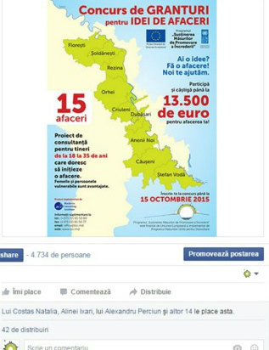
The SCBM Programme had an active communication process in the first year of its fourth phase. An improved communication and visibility strategy was developed based on EU and UNDP requirements. A visibility checklist, coordinated with the EU Delegation Communication and Publications Project Manager, was drafted and is shared with Programme partners who implement sub-projects. Throughout 2015, the Programme team organized 7 events of different format communicating to the public at large on the achievements of the programme.
Facebook post with 42 shares, almost 5000 views
Re-opening of the Caragas kindergarten, May 2015
Social media were actively used to inform the public about the Programme’s achievements, promote key messages concerning confidence building and maintain the identity of the Programme. In this period, The Programme team took active part in public events organised by the EU and UN, such as the Europe days and UN Week. A full range of visibility materials were developed and disseminated during the multitude of events organized. All visibility materials were updated taking into account EU visibility and communication rules.
The SCBM Programme participated actively in the EU Delegation media awareness campaign Moldova in line with Europe, with more than 22 success stories related to SCBM results, including in outlets read by the population on the left bank of the Nistru River. The detailed Communications and Visibility Report (Annex 1) shows the extensive coverage of the SCBM activities and events throughout 2015 in media on both banks of the Nistru River.

FUTURE PLANS

The following implementation period will be from 1 January to 31 December 2016 and coincides with political uncertainty on both sides of the Nistru River, aggravated by a serious economic recession. This calls for additional efforts to coordinate the implementation of Programme’s activities with the stakeholders, with a view to ensuring targets’ achievement.

Since the start of the project in March, several needs assessment activities were initiated, seeking to formulate recommendations on targeted interventions under both components, as well as to consolidate the impact of projects implemented during previous phases with a focus on promoting cross-river cooperation and people-to-people interaction. Drawing up from the lessons learnt, upcoming confidence building activities will be tailor-made for each component striving to build trust between communities, while demonstrating the benefits of working together on issues of common interest, such as economic growth, job creation, community development and renovation of social infrastructure.

Some of the key activities planned for the immediate future in each component are outlined below:

Business Development

- Finalize the assessment on export support services available to SMEs on both banks of the Nistru River, identifying specific needs and providing recommendations on how to address them;
- Expert-Grup will develop and present the First Transnistria Economic Brief and organize a two-day Second capacity building workshop for CSOs and other stakeholders from the Transnistrian region;
- Launch, in partnership with Alternative Internationale de Dezvoltare (AID), the project Cooperation and organizational development support for business associations on both banks of the Nistru River, by selecting 10 business associations from both banks to benefit from consulting for organisational development, training, mini-grants and opportunities to establish cross-river cooperation;
- Finalize, with the help of AID, the Study on Business Development Services Market on both banks of Nistru River, which will provide a set of practical recommendations on further development of the Business Development Services market on both banks, based on the findings of the research, interviews, focus group meetings and international experience analysed as a result of the study visits;
- Launch, in February, a Grants competition to support cross-river Business Platforms with the aim of fostering networking, B2B and cross-river cooperation between business communities on both banks. Grants will be awarded to cross-river partnerships between business associations or CSOs from both banks, seeking to promote exchanges of knowledge and experience, joint study visits, organisation of public and business debates, presentation of different business practices, technologies, and other such activities in the specific sector;
- Following the results of the BDS Market study, activities seeking to promote international Certification for Business Consultants will be implemented;
- The possibility to implement a programme to stimulate the provision of business education and other BDS via a subsidy/support scheme will be explored;
- Two sub-projects within the Creation of Job Opportunities through Business Support for Youth initiative will be continued on both banks, with special attention paid to the 14 month coaching/training program and networking; an updated business platform will be launched to support collaboration between young entrepreneurs from both banks of the Nistru River www.business-bridges.net;
- Finalize the Study on the entrepreneurship perception among youth on the left bank and develop, based on its recommendations, targeted activities to promote a culture of entrepreneurship among youth in the region.

Social Infrastructure component

- Complete the currently on-going 20 infrastructure projects throughout 2016 and 2017;
- Select and approve the remaining 10 infrastructure projects (8 on the left bank and 2 on the right bank);
- Continue to provide capacity development, with the help of the contracted companies, and confidence building actions plans for all 30 social infrastructure object selected for funding, as well as activities and events (instruction, joint activities, study visits) in 2016 and 2017. Also, the two consulting companies will provide coaching and monitoring to the work/initiative groups from all 30 communities to ensure the successful implementation of the projects;
- Finalize the detailed review of 40 social infrastructure projects implemented during 2012-2015 (SCBM III) started by an expert in December 2015, focusing on the operationalization of the renovated objects and sustainable management by the local authority while identifying opportunities for enhancing the social impact on the community. Recommendations will include possibilities to increase the impact, and on promoting cross-river cooperation and people-to-people interaction;
- Analyse the results of the assessment of data users-producers’ capacities on both banks of Nistru River and elaborate, on the basis of its recommendations, training activities to further improve statisticians’ and data users-producers’ capacities;
- Organise learning activities for statisticians and relevant specialists from both banks to produce qualitative and reliable statistical data and foster dialogue between experts in the field.

ANNEXES

- Communication and Visibility Report
- List of activities - Business Development and Employment Opportunities
- List of Community Infrastructure Projects
- Minutes of the Board Meetings and decisions from 27 March, 17 June, and 22 October 2013 (hardcopy)
- Map of Community Infrastructure Projects (hardcopy)
- Regional Economic review: Transnistrian Region (electronic version)

Annex 1: Key Results measured in accordance with the Description of Action Results and Resources Framework
INTENDED OUTPUTS | OUTPUT TARGETS FOR 2015-2017 | KEY RESULTS ACHIEVED
Output 1 - Business development and employment opportunities:  Increased cross-river cooperation of economic actors leading to improved employment opportunities and livelihoods across the Nistru/Dniestr River  Baseline:  - Limited cross-river business exchanges  - Lack of efficient permanent qualitative business advisory and development services for the SMEs in Transnistria region as well as initiatives that would establish contacts between SMEs on both sides of the Nistru River  Indicators:  - Number of cross-river partnerships and business-exchanges  - Number of enterprises that benefited from business support services (disaggregated by region, and women led enterprises)  - Number of full time equivalent jobs created for men and women 15 or more years old  - Number of women and men benefiting from strengthened livelihoods  - Existence of the local consultancy market/ Number of trained and/or certified business consultants  - Number of new business created (including led by women) and integrated in cross-river platforms created as a result of an improved culture of entrepreneurship and greater access to information and funding | Targets 2015  - At least 10 cross-river business exchanges and partnerships supported  - 40 enterprises from both banks benefitting from business support services (20% women led enterprises; 50% from Transnistrian region)  - At least 40 new jobs additionally created, (at least 40% for women, at least 50% in Transnistrian region)  - At least 1,000 women and men (50% women) benefiting from strengthened livelihoods  - Initial activities in view of consolidating local consultancy market providing improved services fostering local capacities to use the benefits provided by the DCFTA in terms of access to the EU market (partners identified and training programs set out)  Targets 2016  - At least 20 additional cross-river business exchanges and partnerships supported  - 100 additional enterprises from both banks benefitting from business support services (20% women led enterprises; 50% from Transnistrian region)  - At least 60 new jobs additionally created, (at least 40% for women, at least 50% in Transnistrian region)  - At least 2,500 women and men (50% women) benefiting from strengthened livelihoods  - At least 10 consultants trained and certified to provide competitive services to beneficiaries on both banks  - At least 10 new businesses additionally created as a result of an improved culture of entrepreneurship and greater access to information and funding and integrated in cross-river platforms  Targets 2017  - At least 20 additional cross-river business exchanges and partnerships supported  - 60 additional enterprises from both banks benefitting from business support services (20% women led enterprises; 50% from Transnistrian region)  - At least 50 new jobs additionally created, (at least 40% for women, at least 50% in Transnistrian region)  - At least 1,500 women and men (50% women) benefiting from strengthened livelihoods  - At least 10 consultants additionally trained and certified to provide competitive services to beneficiaries on both banks  - At least 20 new businesses (including 20% led by women) additionally created as a result of an improved culture of entrepreneurship and greater access to information and funding and integrated in cross-river platforms | Results 2015  - At Least 10 Cross-River Business Exchanges And Partnerships supported  - At least 60 enterprises from both banks (28 from TN) benefitted from business support services  - More than 150 jobs on track of being created (more than 40% for women, 78 in the Transnistria region)  - At least 2,000 women and men benefitted from access to opportunities for improved livelihoods  - A Needs Assessment study currently carried out by a cross-river partnership is formulating the main needs of the local consultancy market, based on field research and results of study visits and is developing a concrete set of recommendations, including training programs, potential partners, etc.
Output 2: Empowered communities and infrastructure support  Empowered local communities and actors from both sides to participate in collaborative projects addressing pressing development needs and improving critical community infrastructure  Baseline:  - Low level of openness and trust towards development support received  - Weak capacity of local actors to pursue sustainable development and implement development projects  - Poor quality of local infrastructure /Limited rehabilitation of environmental and social/medical institutions in the Transnistrian region  - Limited access of people from the Transnistrian region and the security zone to quality social and health services  Indicators:  - Level of openness and trust towards development interventions  - Number of local actors with increased capacities for sustainable development  - Number of social infrastructure projects supported in the security zone on both banks  - Number of people benefited from improved services and various forms of cooperation (disaggregated by sex and geographical coverage)  - No of statisticians whose capacities to collect & produce quality data (in specific statistical areas) were built, to make more data available for the research and policy development  - % of infrastructure projects receiving a quality rating of satisfactory overall or higher | Targets 2015  - Increased level of openness and trust toward development support received  - At least 20 local actors with improved capacity for implementing development projects  - At least 16 social infrastructure projects initiated on both banks of the Nistru River (at least 50% in the TN region). At least 2 social infrastructure projects completed  - At least 10,000 women and men benefiting from improved services and small infrastructure, enjoying better access to basic community services  - At least 2 learning activities in at least 2 statistical areas implemented  - At least 75% of the total number of projects implemented with a quality rating of satisfactory overall or higher  Targets 2016  - Increased level of openness and trust toward development support received  - At least 30 local actors with improved capacity for implementing development projects  - At least 14 social infrastructure projects initiated on both banks of the Nistru River (at least 50% in the TN region). At least 16 social infrastructure projects completed.  - At least 50,000 women and men benefiting from improved services and small infrastructure, enjoying better access to basic community services  - At least 3 learning activities in at least 3 statistical areas implemented. Capacities of minimum 30 professionals from both banks increased.  - At least 75% of the total number of projects implemented with a quality rating of satisfactory overall or higher  Targets 2017  - Increased level of openness and trust toward development support received  - At least 10 local actors with improved capacity for implementing development projects  - At least 12 social infrastructure projects completed (at least 50% in the TN region)  - At least 40,000 women and men benefiting from improved services and small infrastructure, enjoying better access to basic community services  - Increased compliancy to international statistics standards  At least 75% of the total number of projects implemented with a quality rating of satisfactory overall or higher | Results 2015  - High interest in from communities on both banks of the Nistru River: 95 communities, including 39 from the Transnistrian region, submitted 135 social infrastructure project proposals aimed at addressing community development needs in areas of education, culture, sport, health care, water supply and sewerage, social services, road infrastructure;  - Over 30 local actors on both banks with improved capacities to implement development projects;  - 20 social infrastructure projects initiated (7 in the Transnistria region)  - More than 64,000 women and men (>55% women) to benefit directly from improved services provided by the social infrastructure objects;  - A training on the use of gender-related statistical data and a study to assess data users capacities on both banks of the Nistru river implemented;

Annex 2: List of Business Development and Employment Opportunities projects

Number of Sub-Projects: 12
Total budget committed for sub-projects: 1,049,841 EUR

Supporting Business-to-Business Activity

      - Title: Study on institutional development needs of Associations targeting Cross-River Business Cooperation and Economic Development
Implementer: National consultants on Cross-River Business Cooperation and Economic Development Georgeta Mincu and Ana Micolisina
Main Objectives: Assess the opportunities and services available for business communities on both banks of the Nistru River, and analyse the needs of Business Associations related to their organisational development, capacities for B2B and cross-river cooperation, as well as their ability to network and share knowledge, experience and best practices.
Budget: 15,730 Euro
Implementation period: May 2015 – December 2015
Beneficiaries: business associations, business communities, small and medium-sized enterprises, analysts, researchers, practitioners from both banks of the Nistru River

Main activities/results:
- A research study examining the state of cross-river B2B activity and business cooperation at the level of associations and Chambers of Commerce, an assessment of business cooperation and economic development needs has been carried out;
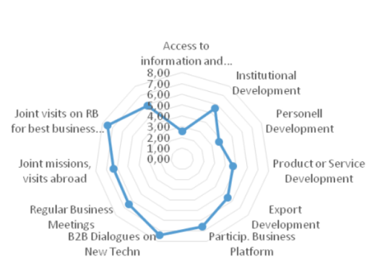
- Field research has been conducted through interviews and online survey with business actors and business associations, as well as other stakeholders on both banks, including previous and current SCBM partners and beneficiaries. Companies from both banks of the Nistru River – about 250 from the left bank and 700 from the right bank, respectively, had been invited to participate in the online survey out of which 55 respondents took part. Additionally, 15 institutions were interviewed during face to face semi-structured interviews on cross-river cooperation in order to get more sense of their needs;
Ranking of business needs for cross-river cooperation
- A mapping and detailed analysis of key partners and projects has been outlined to identify existing interaction platforms and patterns, partnership opportunities, as well as cross-cutting constraints and bottlenecks in promoting cross-river business cooperation and development;
- A Roadmap on institutional development support to business associations has been elaborated to strengthen cross-river cooperation and ensure a permanent cross-river economic dialogue;
- Three Project initiatives for more than 5 activities on providing targeted institutional development and support to business cooperation networks and platforms have been elaborated:
  - Terms of Reference on Cooperation and organizational development support for business associations on both banks of the Nistru River;
  - Terms of Reference on Strengthening B2B Cooperation through Business Platforms on both banks of the Nistru River;
  - Terms of Reference on Developing Companies’ Competitiveness through Quality improvements and understanding of product requirements for placing on the foreign market.

The results of the study will be used to target activities related to Cross-River Business Cooperation, competitiveness, supporting BAs.
Current Status: completed

      - Title: Assessment of export support services available to SMEs on both banks of the Nistru River
Implementer: National consultant on Export Support Services Georgeta Mincu
Main Objectives: To carry out an assessment of export support services available to SMEs on both banks of the Nistru River with a view to identify specific needs and provide recommendations on how to address them
Budget: 6,601 Euro
Implementation period: June 2015 – March 2016
Beneficiaries: business communities, small and medium enterprises, analysts, researchers, practitioners from both banks of Nistru River
Main activities/results:
- A detailed work plan including the proposed methodology for the implementation of the assignment developed;
- Study of export support services available to SMEs on both banks of the Nistru River ongoing.

The results of the study will be used to focus and tailor activities related to export promotion within SCBM.

Current Status: ongoing

      - Title: Transnistrian Economic Review: Engaging stakeholders from both banks of the Nistru River in evidence-based discussions about the economic situation in the Transnistrian region

Implementer: Independent Analytical Centre Expert-Grup

Main Objectives: Carry out economic research and develop forecasts on the economic situation of the Transnistrian region and engage stakeholders from both banks in discussions centred on robust economic and statistical evidence, as well as develop local capacities for evidence-based policy making and advocacy.

Budget: 60,843 Euro

Implementation period: October 2015 – October 2016

Beneficiaries: direct – 11 participants, including 6 women, who took part in the workshop activities, and 42 participants at the round table presentation; indirect - around 400 people from both banks, including CSOs, academia, private sector and media representatives from the Transnistrian region and from the rest of the country who are interested in the Transnistrian region
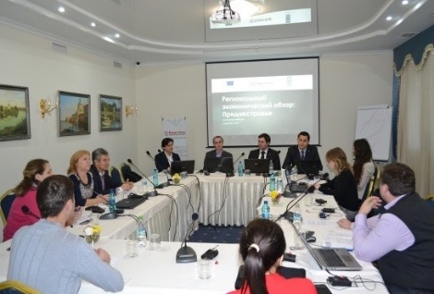
Expert-Grup workshop on policy analysis and advocacy
Main activities/results:
- 11 representatives of CSOs and academia from the Transnistrian region had developed their skills on evidence-based policy analysis and advocacy during a 2-day workshop;
- The Regional Economic Review: Transnistria, was published and presented at a round table attended by 42 participants from both banks of the Nistru River.

Sustainability: 11 economic experts from the Transnistrian region have improved their knowledge and capacities to promote evidence-based policy making; 42 participants at the round table on Regional Economic Review improved their knowledge, enabling them to use the acquired information and tools in their activity. The participants agreed to organize similar activities in the future, including in the Transnistrian region.

Current Status: ongoing

      - Title: Support to promote exports for light industry producers on both banks: Participation at the GDS Duesseldorf international exhibition
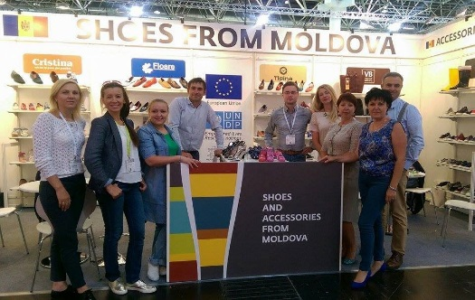
Moldovan producers from both banks at GDS Duesseldorf
Implementer: Association of Light Industry of Moldova (APIUS)

Main Objectives: Improve the skills and capacity of companies from both banks and their industry association to participate at international exhibitions with the aim of enhancing the export and improving the visibility of Moldovan footwear and accessories producers on the European market

Budget: 8,412 Euro (SCBM contribution; approx. 5000 EUR contribution from participating companies/APIUS)

Implementation period: July 2015

Beneficiaries: direct – 5 SME participants from both banks; indirect - more than 1,700 employees (including 1,200 women)

Main activities:
- During 29-31 July, 5 companies from both banks, including 2 from the Transnistrian region (Tighina and Floare footwear factories) participated with a joint stand representing Moldova at the largest shoes and accessories fair in the world, GDS, in Duesseldorf, Germany;
- 16 useful business contacts between the participants from both banks were established as a result of participation at the exhibition;
- Oldcom JSK already delivered its first order to a Russian client found at Duesseldorf and plans to launch exports to Romania in 2016.
- Contacts with new suppliers of raw materials have been established.

Sustainability: 5 companies improved their skills and capacities to participate at international exhibitions more professionally. They have gained valuable experience and improved export promotion tools enabling them to use them in the future. The newly established 16 business contacts will create additional jobs and improve livelihoods of current employees of the companies.

Current Status: completed

      - Title: Seminar of Fruit producers from both banks

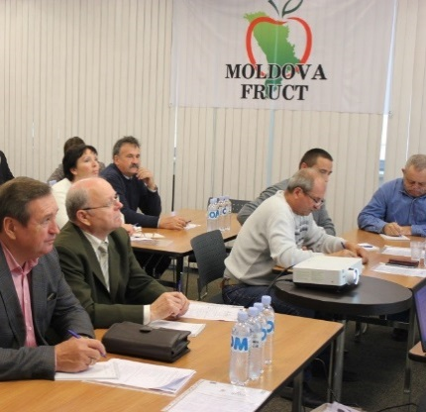
Implementer: Association of Fruit Producers and Exporters Moldova Fruct (right bank) and Association of Fruit Producers Dnestrovskii Fruct (left bank)
Fruit producers associations’ seminar, Chisinau, 2015

Main Objectives: To improve the cooperation between associations of fruit producers from both banks; deliver training on orchards preparation for the winter

Budget: 189 Euro + Conference hall provided for the meeting (Italian trainer funded by Moldova Fruct)

Implementation period: October 2015

Beneficiaries: direct – 39 participants (including 10 women), representing 24 fruit producers from both banks; indirect - more than 500 employees of these companies;

Main activities/results:
- A protocol of cooperation and a joint work plan for 2016 was signed for the first time, thus extending economic opportunities in the field of agriculture for local communities on both banks;
- 39 participants from both banks have now improved skills in the area of apple orchards preparation for the winter based on the experience of Italian apple producers.

Sustainability: Signing the Memorandum of cooperation between the associations of producers of apples from both banks is a first step for future collaboration and a good example for other associations.

Current Status: completed

      - Title: Cooperation and organizational development support for business associations on both banks of the Nistru River

Implementer: Alternative Internationale de Dezvoltare

Main Objectives: Improve the opportunities and services available for business communities on both banks of the Nistru River by supporting BAs in their organizational development, their capacities for B2B and cross-river cooperation, as well as their ability to network and share knowledge, experience and best practices

Budget: 179,264 Euro

Implementation period: December 2015 - November 2017

Beneficiaries: BAs from both banks; indirect – business communities, small and medium enterprises from both banks of Nistru River

Main activities:
- Contract signed in December 2015;
- A work plan, including the proposed methodology for the implementation of the assignment, is in the process of development.
- Planned activities include the selection of 10 business associations (BAs), 5 from each bank, to benefit from support related to the development of existing or new Organisational Development Plans (ODPs) focussed on improved service provision to members and a stronger cross-river cooperation component, provision of trainings, organisation of 2 study visits to EU countries, as well as 4 study visits to the other bank, provision of mini-grants to BAs in implementing parts of their ODPs as well as in delivering joint activities, etc.

Sustainability: a network of BAs from both banks will be created as a result of implementation of this project. Consolidated BAs can serve as champions in advancing business community cooperation between both banks, and their improved service profiles will make them more relevant for their members.

Current Status: launched

      - Title: Strengthening B2B Cooperation through Business Platforms on both banks of the Nistru River

Implementer: TBD

Main Objectives: Improve the opportunities for business communities on both banks of the Nistru River by supporting cross-river partnerships in implementing activities aimed at networking, B2B and cooperation, sharing knowledge, experience and learning best practices for increasing business competitiveness locally and on foreign markets.

Budget: TBD

Implementation period: Febryart 2016 - TBD

Beneficiaries: BAs, NGO from both banks; indirect – business communities, small and medium enterprises from both banks of Nistru River

Main activities:
- A Grants competition to support cross-river Business Platforms to be launched in February;
- Draft grant applicants’ guidelines were developed.

Sustainability: Cross-river cooperation platforms will be created, and the applicants are required to present a 2 year post-project sustainability plan at the application phase already.

Current Status: in the process of launching

Stimulating Business Development Services

- Title: Study on Business Development Services Market on both banks of Nistru River

Implementer: Alternative Internationale de Dezvoltare, Chisinau, and the Centre for analytical research New Age from Tiraspol

Main Objectives: Carry out an in-depth analysis of the Business Development Services market on both banks of the Nistru River and present a set of recommendations for the further development of the sector

Budget: 67,877 Euro

Implementation period: August 2015 – February 2016

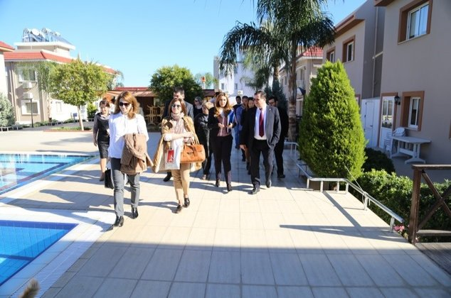
Beneficiaries: direct – 23 participants at study tours (including 13 women) and 40 participants at focus groups, including at least 20 women; indirect - more than 64 SME from both banks, including 32 from TN, business communities on both banks in general

Main activities/results:
- More than 60 interviews face-to-face have been conducted on both banks of Nistru river with various stakeholders, Business Development Service Providers and representatives of Business Communities, selected based on approved criteria:
Moldovan delegation in Cyprus, December, 2015
- 21 interviews with Business Development Service providers conducted and (11 right bank and 10 left bank);
- 22 interviews with representatives of Business Communities conducted (12 right bank and 10 left bank);
- 21 interviews with representatives of various stakeholders, including representatives of public institutions conducted (11 right bank and 10 left bank);
- 34 questionnaires received from the right bank of Nistru River have been processed.
- Online survey questionnaires for representatives of business community on both banks has been developed and piloted among a few business community representatives;
- 2 study visits organised for Moldovan Business Development Services Providers and stakeholders from both sides of Nistru River to learn from the international experience of Business Development Services sector in Poland and Cyprus;
- 12 Business Service providers (including 8 women) participated at a study visit in Poland and have now improved skills and understanding of more effective business methods and good practices in the fields of agriculture, industry, technology parks, tourism, SME development and banking services;
- 11 Business Service providers (including 5 women) participated at a study visit in Cyprus. The participants improved their understanding about development and good practices of building entrepreneurial friendly environment in a post-conflict country;
- 2 focus groups meetings organised with participants from both banks of the Nistru River - representatives of BDS companies, business community and relevant stakeholders over the issues concerning the Business Development Service sector. Participants were strongly in favour of creating a joint association of business consultants involving representatives from both banks;

Sustainability: The Rezina Business Incubator agreed with a counterpart from the Transnistrian region (Intereconomservice, Ribnitsa) to undertake future joint projects - organise cross-river discussions to better understand DCFTA requirements for export and address the challenges faced in the Transnistrian region, also in cooperation with EBA (European Business Association). The established cooperation will ensure further durability of project results.

Current Status: ongoing

Promoting a Culture of Entrepreneurship and Support Young Entrepreneurs

- Title: Creation of Job Opportunities through Business Support for Youth on the Right bank

Implementer: Business Consulting Institute NGO

Main Objectives: Creation of job opportunities for young women and men (18 to 35 years old) from the targeted communities on the right bank by providing support to start and run effectively a business, as well as establishing opportunities to network and share knowledge and best practices

Budget: 336,326 Euro

Implementation period: July 2015 – April 2017

Beneficiaries: direct – 15 grant beneficiaries from targeted communities assisted, including 10 women, indirect – 152 people (72 jobs created + 80 courses participants),

Main activities:
- 80 (41 women, 40 men) candidates passed trainings on business plan writing;
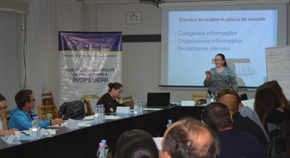
- 75 hours of individual consultations on all aspects of business plan writing provided to 80 candidates;
- 15 grant beneficiaries (including 10 women) from Anenii Noi, Causeni, Dubasari , Orhei , Rezina , Soldanesti and Stefan Voda were selected and received grants of up to 13,500 Euro, individual coaching and provision of business support services;
- 72 jobs on track of being created. Livelihoods of 80 people who participated at crash courses improved. In total, livelihoods of 152 people have received additional support.
Training on Business plan development, Chisinau, 2015
- A business platform for supporting collaboration between young entrepreneurs from both banks of the Nistru River is currently being developed: www.business-bridges.net.

Sustainability: a network of young entrepreneurs has been created as a result of implementation of two mirror projects which will ensure further durability of project results. Several beneficiaries foresee further development and extension of their businesses, including on the opposite bank.

Current Status: ongoing

- Title: Creation of Job Opportunities through Business Support for Youth in Transnistrian region

Implementer: Chamber of Commerce and Industry of Transnistria

Main Objectives: creation of job opportunities for young men and women (18 to 35 years old) in the Transnistrian region by providing support to start and run effectively a business, as well as establishing opportunities to network and share knowledge and best practices

Budget: 349,340 Euro

Implementation period: July 2015 – April 2017

Beneficiaries: direct – 15 grant beneficiaries assisted in the Transnistrian region, including 8 women, indirect – 224 people (78 jobs created, including 35 women and 1 person with disabilities) + 146 courses participants (51 women)

Main activities:
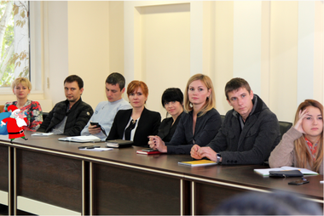
- 146 applicants (including 51 women) benefitted from 4 one-day trainings courses on business plan writing (2 in Tiraspol, 1 in Bendery, 1 in Rybnita);
- 52 candidates (15 women, 37 men) received individual consultation, totalling 75 hours of consultations on all aspects of business plan writing;
- 15 grant beneficiaries (including 9 women) from Tiraspol, Bendery, Grigoriopol, Ribnita, Slobozia, Dnestrovsc and Dubasari were selected and received grants of 9,400-13,500 Euro, continuous individual coaching and provision of business support services;
Business plans presentation, Tiraspol, 2015
- 78 jobs on track of being created (35 women). 146 livelihoods of people who participated at crash courses were improved. In total, livelihoods of 224 people improved.

Sustainability: a network of young entrepreneurs created as a result of implementation of two mirror projects will ensure further durability of project results. Several beneficiaries foresee further development and extension of their businesses, including on the opposite bank.

Current Status: ongoing

- Title: Study on entrepreneurship perception among youth on the left bank of the Nistru River

Implementer: CBS-AXA in cooperation with MiLab and Centre Resonance from the Left Bank

Main Objectives: design and carry out a study among young (aged 18 to 35) women and men in the Transnistria region on their perceptions of entrepreneurship and come up with recommendations on promotion of a culture of entrepreneurship in the respective area.

Budget: 23,316 Euro

Implementation period: October 2015 - February 2016

Beneficiaries: direct - 30 youth from both banks of the Nistru River (16 women and 14 men); indirect - business communities, associations, analysts, researchers, entrepreneurs from both banks of Nistru River

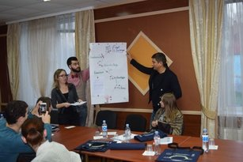
Main activities:
- Field Research - research activities (interviews and Survey), based on earlier approved tools & methodologies have been carried out;
- Innovative Design Thinking Workshop - a two-day event with 30 university students (16 women and 14 men) from both banks (15 from each bank) successfully organised in partnership with MiLab and Rezonans from the left bank;
- The opinion poll and in-depth interviews in Transnistria foreseen in January-February 2016
Team work on entrepreneurship perception among youth, Vadul-lui-Voda, 2015

The participants have gained valuable experience and knowledge about the design thinking and culture of entrepreneurship and had the opportunity to network with their colleagues and experts and establish valuable links for future cooperation. The training as well as extra-training activities were conceived to assure a large communication between the youth from both banks.

Current Status: ongoing

- Title: Forum of Young entrepreneurs

Implementer: NGO National Association of Young Managers (ANTiM) in cooperation with Argidius foundation

Budget: 1,943 Euro (co-funded by SCBM)

Implementation period: December 2015

Beneficiaries: 121 participants, 59 women, including Transnistria young entrepreneurs

Main activities:
- A one-day forum The realities and the potential for business development for young entrepreneurs brought for the first time together in such a format young entrepreneurs from both banks;
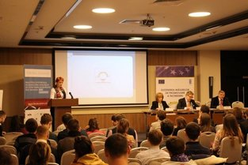
- 121 participants / 59 women involved. They were able to network while successful entrepreneurs and experts shared with them the most efficient management and business development approaches;
- At least 10 young entrepreneurs from the Transnistria region participated, 2 of them as guest speakers sharing their own entrepreneurship experience;
- On-going programs and projects offering support to young entrepreneurs were presented by representatives of EU, UNDP, CCM, IFAD, the World Bank (PAC II);
ANTIM Forum for young entrepreneurs, Chisinau, December, 2015
- 6 parallel training sessions provided on Access to finance, Leadership and management communication, Platform for Learning, Business development, Franchising and others.

Sustainability: 121 participants, 59 women, have gained valuable experience and knowledge about development opportunities and had the opportunity to network with their colleagues and experts and establish durable liaisons for future cooperation; ANTiM extended its network to the Transnistria region and decided to involve local representatives in its activities in the future

Current Status: completed

Annex 3: List of Community Infrastructure Projects

Number of Sub-Projects: 24
Total budget committed for sub-projects: 3,439,603 EUR
Communities’ contribution: 86,447 EUR
Number of direct beneficiaries: 64,733 (women: 34,183 and men: 30,550)

Sub-Project 1: Overall renovation of the Rascov Community Centre
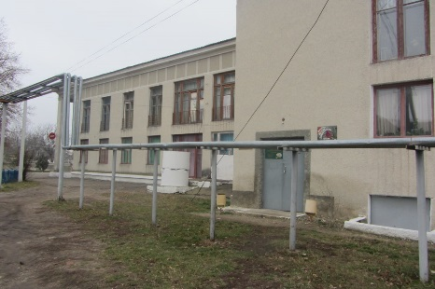
Implemented by: SCBM Programme

Direct beneficiaries: 2,097 (village population): 1,085 women/795 men

Budget estimation: 171,354 EUR
Additional local contribution: 0 EUR

Timeframe: January 2016 – November 2016

Overall goals of the project: improved conditions for socio-cultural activities in the community

Status: works in progress

The implementing partner expert team (Interaction) is in the course of establishing the local implementation team. All cost estimates have been carried out; a construction company has been selected through a public tender but the contract was not signed yet following the results of a technical expertise indicating the need for further consolidation of the entire resistance frame/structure. The EU Delegation has been duly informed that the preliminary technical expertise has spotted problems in the corners of the building, roof and windows – that would require additional works for their consolidation. While it is difficult to estimate more precisely at the moment some 50-60,000 USD would be needed additionally to renovate this object. To be able to know the exact amount, one would need to conduct an in-depth technical expertise of the entire building (we did a preliminary one of the roof) + elaboration of engineering solutions, followed by costs estimates (these are specialized technical engineering procedures that would cost around 5,000 USD in total). Also, this might mean only technical works would be feasible, while for other issues like furniture (chairs ) and any other that could be considered stand-alone to engage other partners.
_____________________________________________________________________________________

Sub-Project 2: Overall repair of the Child and Youth Creativity Hall in the town of Dubasari
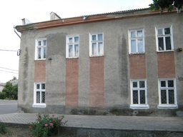
Implemented by: SCBM Programme

Direct beneficiaries: 2,242 (842 children and 1,648 parents): 1,390 women and 1,082 men

Budget estimation: 136,614 EUR
Additional local contribution: 12,900 EUR

Timeframe: January 2016 – August 2016

Overall goals of the project: complete renovation of the Child and youth creativity hall to improve the conditions for activity organization, thus enhancing its capacity and increasing the number of beneficiaries.

Status: works in progress

The implementing partner expert team (Interaction) is in the course of establishing the local implementation team. All technical and expenditures estimates have been carried out; a construction company has been contracted following a public tender to run the works. The selected company (Iati SRL) will start the works on 10 January 2016 because prior to this date the facility is being used for social and cultural events and activities. The rehabilitation of the premises is expected to be completed in August 2016.
_____________________________________________________________________________________

Sub-Project 3: Replacement of heating system and doors, construction of lavatories, renovation of the sports and conference halls (General education school/kinder garden no. 2) in Nezavertailovka
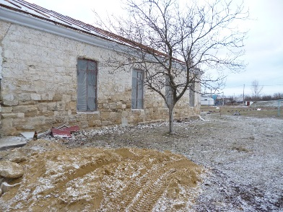
Implemented by: SCBM Programme

Direct beneficiaries: 746 (225 children+71 staff+450 parents): 395 women and 351 men

Budget estimation: 152,262 EUR
Additional local contribution: 0 EUR

Timeframe: January 2016 – May 2016

Overall goals of the project: increase the heat retention rate during cold seasons by replacing the doors and repairing the heating system. Also, minimize the probability of injuries due to inappropriate conditions in the sports and conference halls. Increase the sanitary standards of the building by including indoor lavatories.

Status: works in progress

The implementing partner expert team (Interaction) undertook work visits to the village and elaborated community needs assessment reports, capacity gaps assessments and community development and confidence building action plans. All technical and expenditures estimates have been carried out; a construction company has been contracted following a public tender to run the works. The selected company, Provalenta SRL, completed all works related to the heating system, also plumbing works at the lavatory have been initiated. The rehabilitation of the auxiliary building have started with the replacement of the roof and floor. The rehabilitation of the premises is expected to be completed in May 2016.
_____________________________________________________________________________________

Sub-Project 4: Renovation of School no. 2 in Chitcani
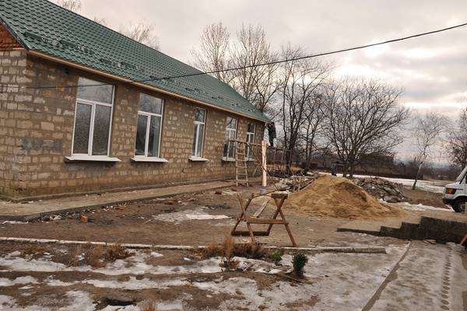
Implemented by: SCBM Programme

Direct beneficiaries: 1,023 (420 pupils+550 parents+53 staff): 544 women and 479 men

Budget estimation: 144,618 EUR
Additional local contribution: 0 EUR

Timeframe: January 2016 – May 2016

Overall goals of the project: increase the heat retention rate during cold seasons by replacing the doors and repairing the heating system. Also, minimize the probability of injuries due to inappropriate conditions in the sports and conference halls. Increase the sanitary standards of the building by including indoor lavatories.
Status: works in progress

The implementing partner expert team (Interaction) undertook work visits to the village and elaborated community needs assessment reports, capacity gaps assessments and community development and confidence building action plans. All technical and expenditures estimates have been carried out; a construction company has been contracted following a public tender to run the works. The selected company Stagor started reconstruction works and partially replaced the roof of the central building and fully replaced the roof for the auxiliary building. Currently refurbishment works are carried out in the cafeteria. The rehabilitation of the premises is expected to be completed in May 2016.
_____________________________________________________________________________________

Sub-Project 5: Replacement of windows, repair of roof and cafeteria/festivity hall for the school in Glinoe

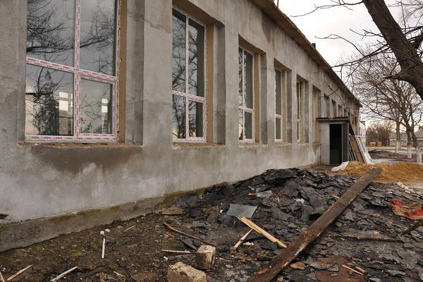
Implemented by: SCBM Programme

Direct beneficiaries: 750 (250 pupils+500 parents): 380 women and 370 men

Budget estimation: 134,855 EUR
Additional local contribution: 0 EUR

Timeframe: January 2016 – June 2016

Overall goals of the project: increase the heat retention rate during cold seasons by replacing the doors and windows with insulated glazing.

Status: works in progress

The implementing partner expert team (Interaction) undertook work visits to the village and elaborated community needs assessment reports, capacity gaps assessments and community development and confidence building action plans. All technical and expenditures estimates have been carried out; a construction company has been contracted following a public tender to run the works. The selected company Stagor replaced the roof of the sports hall and initiated refurbishment works. The rehabilitation of the premises is expected to be completed in June 2016.

__________________________________________________________________________________

Sub-Project 6: Renovation of the town polyclinic in Dnestrovsk
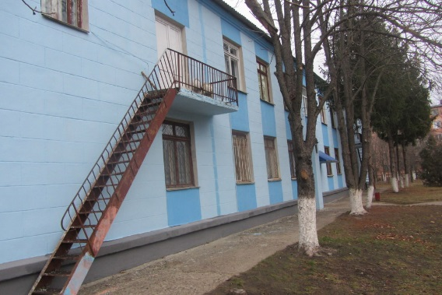
Implemented by: SCBM Programme

Direct beneficiaries: 15,072 (15,000 yearly capacity of patients+72 staff): 7,868 women and 7,204 men

Budget estimation: 144,884 EUR
Additional local contribution: 0 EUR

Timeframe: January 2016 – May 2016

Overall goals of the project: Repair the wiring and sewerage systems, replacement of floors and roofing, thus improving the conditions for patients and staff (total of 72) of the polyclinic.

Status: works in progress

The implementing partner expert team (Interaction) undertook work visits to the town of Dnestrovsk and elaborated community needs assessment reports, capacity gaps assessments and community development and confidence building action plans. All technical and expenditures estimates have been carried out; a construction company has been contracted following a public tender to run the works. The selected company, Provalenta replaced the heating system on the second floor and began refurbishment works. Also, works for the replacement of the roof and doors have been started. The rehabilitation of the premises is expected to be completed in May 2016.
_____________________________________________________________________________________

Sub-Project 7: Renovation of the centre for victims of human trafficking in Tiraspol
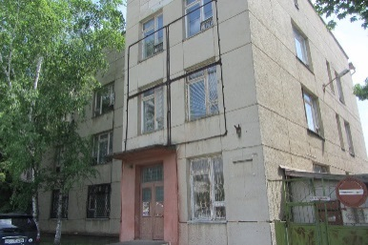
Implemented by: SCBM Programme

Direct beneficiaries: 129 (120 persons assisted per year + 9 staff): 67 women and 62 men

Budget estimation: 243,294 EUR
Additional local contribution: 4,715 EUR

Timeframe: January 2016 – May 2017

Overall goals of the project: renovation of a building wing formerly used as a children hospital and adapt it to accommodate the Centre for victims of human trafficking.

Status: works in progress
The implementing partner expert team (Interaction) is in the course of establishing the local implementation team. All technical and expenditures estimates have been carried out; a construction company has been contracted following a public tender to run the works. The selected company, IGC-Construct has drawn up and now is coordinating the first sketches with the technical plan of the centre. All required documents are being collected from the local administration. The rehabilitation of the premises is expected to be completed in May 2017.
_____________________________________________________________________________________

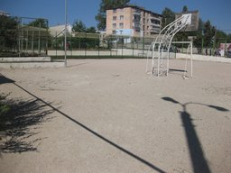
Sub-Project 8: Improvement of educational, socio-cultural and sport services provided by the complex in Varnita (Anenii Noi district)

Implemented by: SCBM Programme

Direct beneficiaries: 2,365 (children, parents and staff): 1,170 women and 1,193 men)

Budget estimation: 139,120 EUR
Additional local contribution: 860 EUR

Timeframe: January 2016 – May 2016

Overall goals of the project: create optimal conditions for the good functioning of the educational, socio-cultural and sports complex in Varnita village

Status: works in progress

A SCBM team representative undertook a site visit and collected information for the capacity assessment report. All technical and expenditure estimates have been carried out; a construction company has been contracted following a public tender to run the works. The selected company, Giesena SRL, started works for replacement of fences and metal constructions. Rehabilitation of the premises is expected to be completed in May 2016.
__________________________________________________________________________________

Sub-Project 9: Renovation of the Community centre in Corjova (Criuleni district)

Implemented by: local public authority of Corjova village

Direct beneficiaries: 2,567 (village population): 1,335 women and 1,232 men

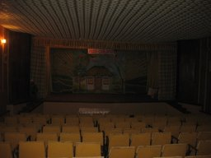
Budget estimation: 140,774 EUR
Additional local contribution: 0 EUR

Timeframe: January 2016 – June 2017

Overall goals of the project: renovation of the village Community centre that serves as host of all socio-cultural and artistic meetings with the scope to strengthen the relationships across the Nistru river (Criuleni on one side and Dubasari and Grigoriopol on the other side).

Status: works in progress

The implementing partner expert team (Contact) visited the community and elaborated needs assessment and capacity gaps reports as well as the capacity development and confidence building action plan. Expenditures estimates for the design company have been drawn up and a design company was selected through a public tender. The selected company, IGC- Construct, is drawing up the design of the boiler/heating system. The rehabilitation of the premises is expected to be completed in June 2017.
__________________________________________________________________________________

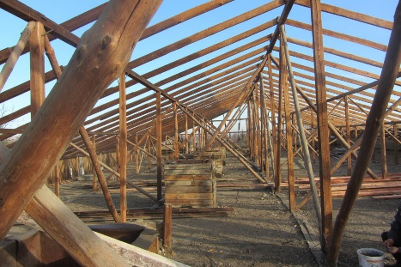
Sub-Project 10: Modernization of the regional cultural centre from Slobozia-Dusca (Criuleni district)

Implemented by: SCBM Programme

Direct beneficiaries: 3,200 (village population): 1,672 women and 1,528 men

Budget estimation: 154,537 EUR
Additional local contribution: 0 EUR

Timeframe: January 2016 – June 2016

Overall goals of the project: To promote and consolidate confidence, cultural and spiritual values, national traditions and customs, by creating optimal conditions to organize joint cultural-artistic activities with people from Slobozia-Dusca, Criuleni, and the villages Harmatca and Tibuleuca, Dubasari district; villages Nezavertailovca and Corotna, Slobozia district, thus offering quality services and diversified cultural activities

Status: works in progress

The implementing partner expert team (Contact) visited the community and elaborated needs assessment and capacity gaps reports as well as the capacity development and confidence building action plan. All technical and expenditure estimates have been carried out; a construction company has been contracted following a public tender to run the works. The selected company, Giesena SRL, replaced the roof and is completing refurbishment works on the second floor. The rehabilitation of the premises is expected to be completed in June 2016.
_____________________________________________________________________________________

Sub-Project 11: Construction and equipment of the Office of Family Physicians from Hagimus (Causeni district)

Implemented by: local public authority of Hagimus village

Direct beneficiaries: 3,038 (1,550 women and 1,488 men)

Budget estimation: 140,874 EUR
Additional local contribution: 10,122 EUR

Timeframe: January 2016 – August 2017

Overall goals of the project: improved conditions for primary medical assistance to people on both banks of the Nistru River leading to consolidated relationship and communication among people

Status: works in progress

The implementing partner expert team (Contact) visited the community and elaborated capacity gaps reports as well as the capacity development and confidence building action plan. Expenditures estimates for the design company have been drawn up and a design company was selected through a public tender. The selected company, IGC- Contruct, is developing the technical documentation for the new Office of the Family Physicians building. The rehabilitation of the premises is expected to be completed in August 2017.
__________________________________________________________________________________

Sub-Project 12: Renovation of the infectious diseases section of the Rezina district hospital
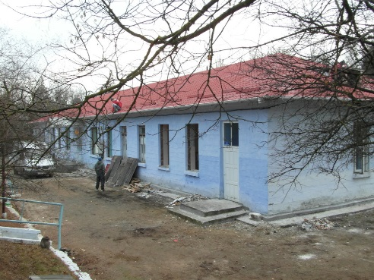
Implemented by: SCBM Programme

Direct beneficiaries: 500 (yearly capacity of section): 260 women and 240 men

Budget estimation: 148,919 EUR
Additional local contribution: 12,259 EUR

Timeframe: January 2016 – July 2016

Overall goals of the project: improved medical infrastructure in the town and district leading to an increased cooperation and interaction between people from both banks of the Nistru River

Status: works in progress

The implementing partner expert team (Contact) visited the town and elaborated capacity gaps reports as well as the capacity development and confidence building action plan. All technical and expenditure estimates have been carried out; a construction company has been contracted following a public tender to run the works. The selected company, Marconex Prim SRL, replaced the roof, completed interior demolishing works and currently assembles the heating system. The rehabilitation of the premises is expected to be completed in July 2016.
__________________________________________________________________________________

Sub-Project 13: Construction of and equipment provision for a sports field and playground at the Latin-script Theoretic Lyceum Evrika from Ribnita town

Implemented by: SCBM Programme

Direct beneficiaries: 469 (pupils, parents and staff): 260 women and 209 men

Budget estimation: 113,160 EUR
Additional local contribution: 0 EUR

Timeframe: January 2016 – May 2017

Overall goals of the project: construction and equipment of the sports field and playground for children of the Theoretic Lyceum ‘Evrica’

Status: works in progress

Expenditures estimates for the design company have been drawn up and a design company was selected through a public tender. The selected company, IGC- Construct, is developing the design of the playground and the sports field. The rehabilitation of the premises is expected to be completed in May 2017.
________________________________________________________________________________

Sub-Project 14: Capital renovation of the bridge on Drumul Tirgului street from Hirbovat (Anenii Noi district)
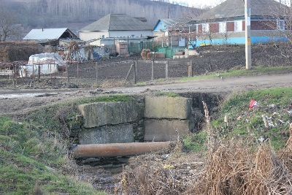
Implemented by: local public authority of Hirbovat village

Direct beneficiaries: 8,690 (5,456 population of Hirbovat + 3,234 population of Protiagailovca): 4,466 women and 4,224 men

Budget estimation: 141,372 EUR
Additional local contribution: 0 EUR

Timeframe: January 2016 – June 2016

Overall goals of the project: increased interaction and cooperation between people from Hirbovat and Protegailovca (left bank) villages through improving accessibility and road safety conditions

Status: works in progress
The implementing partner expert team (Contact) visited the community and elaborated needs assessment and capacity gaps reports as well as the capacity development and confidence building action plan. A Grant Agreement has been signed with the local authorities from the community in December 2015.

_____________________________________________________________________________________

Sub-Project 15: Renovation of the sports complex facility in Serpeni village (Anenii Noi district)
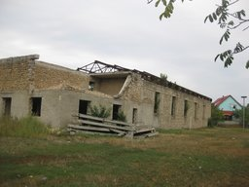
Implemented by: SCBM Programme

Direct beneficiaries: 3,585 (village population): 1,865 women and 1,720 men

Budget estimation: 201,442 EUR
Additional local contribution: 14,071 EUR

Timeframe: January 2016 – December 2017

Overall goals of the project: development of sports and culture infrastructure of Serpeni village

Status: works in progress

The implementing partner expert team (Contact) visited the community and elaborated needs assessment and capacity gaps reports as well as the capacity development and confidence building action plan. Technical works have not been initiated yet.
__________________________________________________________________________________

Sub-Project 16: Renovation of the Molovata village community centre (Dubasari district)
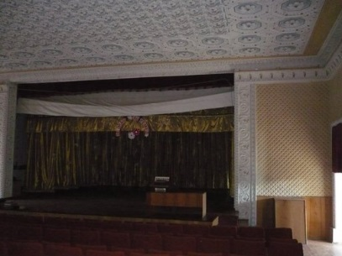
Implemented by: SCBM Programme

Direct beneficiaries: 2,873 (village population): 1,443 women and 1,430 men

Budget estimation: 181,741 EUR
Additional local contribution: 2,205 EUR

Timeframe: January 2016 – August 2016

Overall goals of the project: renovation of the village Community centre that serves as host of all socio-cultural and artistic meetings with the scope to strengthen the relationships across the Nistru River.

Status: works in progress

The implementing partner expert team (Contact) visited the community and elaborated needs assessment and capacity gaps reports as well as the capacity development and confidence building action plan. Technical works have not been initiated yet (the Mayor is expected to provide documents which confirm the connection to infrastructure networks).
_____________________________________________________________________________________

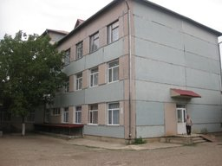
Sub-Project 17: Thermal insulation, replacement of windows and renovation of the stadium for the Cirnateni village lyceum (Causeni district)

Implemented by: SCBM Programme

Direct beneficiaries: 1,111 (pupils, parents and staff): 555 women and 556 men

Budget estimation: 181,297 EUR
Additional local contribution: 9,381 EUR

Timeframe: January 2016 – September 2016

Overall goals of the project: increase the heat retention rate during cold seasons by insulating the building of the lyceum thus improving the education/instruction conditions in “Grigore Grigoriu” lyceum.

Status: works in progress

The implementing partner expert team (Contact) visited the community and elaborated needs assessment and capacity gaps reports as well as the capacity development and confidence building action plan. Technical works have not been initiated yet.

_________________________________________________________________________________________

Sub-Project 18: Renovation of the Dorotcaia village Community centre (Dubasari district)
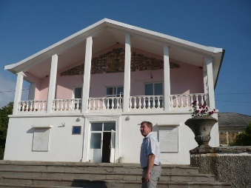
Implemented by: SCBM Programme

Direct beneficiaries: 3,547 (village population): 1,783 women and 1,764 men

Budget estimation: 192,780 EUR
Additional local contribution: 9,381 EUR

Timeframe: January 2016 – October 2016

Overall goals of the project: promotion of social and cultural values aimed at increasing trust between residents of Dubasarii Vechi village and Pirita, Cosnita, Dorotcaia, Delacau, Grigoriopol (town)

Status: works in progress

The implementing partner expert team (Contact) visited the community and elaborated needs assessment and capacity gaps reports as well as the capacity development and confidence building action plan. Technical works have not been initiated yet.
_____________________________________________________________________________________

Sub-Project 19: Reconstruction of the village sewerage system (Speia, Anenii Noi district)
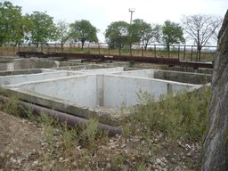
Implemented by: SCBM Programme

Direct beneficiaries: 3,271 (village population): 1,720 women and 1,550 men

Budget estimation: 191,722 EUR
Additional local contribution: 6,941 EUR

Timeframe: January 2016 – August 2016

Overall goals of the project: improved living conditions for Speia and neighbouring villages’ residents by providing a renovated sewerage system (decreased pollution and higher quality infrastructure services)

Status: works in progress

The implementing partner expert team (Contact) visited the community and elaborated needs assessment and capacity gaps reports as well as the capacity development and confidence building action plan. All technical and expenditures estimates have been carried out; a construction company has been contracted following a public tender to run the works. The reconstruction of the sewerage system is expected to be completed in August 2016.
_____________________________________________________________________________________

Sub-Project 20: Renovation of the Office of Family Physicians and establishment of outpatient treatment section in Gura Bicului (Anenii Noi district)

Implemented by: SCBM Programme

Direct beneficiaries: 4,483 (3,600 Gura Bicului population+883 Bicioc population): 2,331 women and 2,152 men

Budget estimation: 155,542 EUR

Additional local contribution: 3,612 EUR

Timeframe: January 2016 – March 2017

Overall goals of the project: a renovated medical facility with an available outpatient unit (capacity: 10 persons) for residents of Gura Bicului and Bicioc villages leading to increased cooperation and interaction between people acros the Nistru River

Status: works in progress

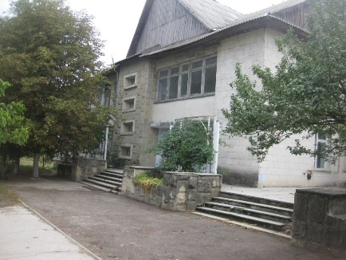
The implementing partner expert team (Contact) visited the community and elaborated needs assessment and capacity gaps reports as well as the capacity development and confidence building action plan. Expenditures estimates for the design company have been drawn up and a design company was selected through a public tender. The selected company, Alexdan SRL, is developing the technical documentation for the object. The rehabilitation of the Office of Family Physicians is expected to be completed in March 2017.
__________________________________________________________________________________

Sub-project 21: Professional Consulting Services provided by CONTACT Centre
Representatives of LPAs during capacity development exercises

Implementer: CONTACT Centre

Main Objectives: contribute to the increase of the capacity of LPAs by providing support in identifying development needs, capacity gaps and confidence building potential in target communities

Budget: 84,868 Euro

Implementation period: July 2015 – June 2017

Beneficiaries: direct – 2,891 persons (1,979 women and 912 men) from 27 community LPAs and local stakeholders (development needs reports) + 10 community LPAs and local stakeholders (capacity gaps assessments and capacity development and confidence building action plans)

Main activities: community capacity needs assessment, capacity gaps assessments, capacity development and confidence building actions plans developed
__________________________________________________________________________________

Sub-project 22: Professional Consulting Services provided by the INTERACTION NGO

Implementer: INTERACTION NGO

Main Objectives: contribute to the increase of the capacity of LPAs by providing support in identifying development needs, capacity gaps and confidence building potential in target communities

Budget: 93,239 Euro

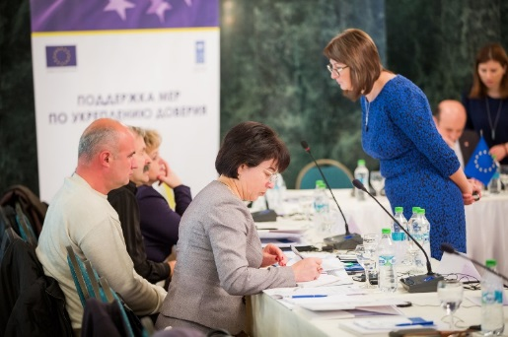
Implementation period: September 2015 – June 2017

Beneficiaries: direct – 74 persons (65 women and 9 men) from 4 community LPAs and local stakeholders (development needs reports, capacity gaps assessments and capacity development and confidence building action plans);

Main activities: community capacity needs assessment, capacity gaps assessments, capacity development and confidence building actions plans developed
Representatives of LPAs from both banks and Interaction NGO during a joint event

__________________________________________________________________________________

Sub-Project 23: Training on interpreting and using gender-related data for mixed data producer-user groups

Implementer: SCBM Programme jointly with the Strengthening the National Statistical System project, UNDP

Main Objectives: To improve the capacities on issues related to gender statistics and increase cooperation between relevant professionals from both banks of the Nistru River

Budget: 2,935 Euro

Implementation period: November 2015

Beneficiaries: direct – 14 participants (including 10 women) from both banks

Main activities:
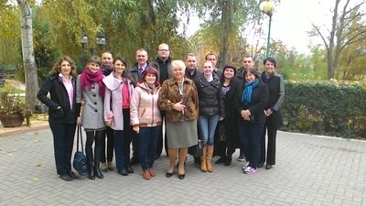
- Statisticians, lectures/teachers and students from economic/sociological faculties, think-tanks (analysts), representatives of sociological companies, civil society organisations from both banks of the Nistru River attended a one-and-a-half days training on improving the capacities on issues related to gender statistics coached by two experts from the United Nations Economic Commission for Europe (UNECE);
- Trainees have now improved skills on international data sources available online containing gender-related data, main data collection methods, including household-based surveys for measuring gender (in)equality, importance of demographic and employment indicators for gender analysis, measuring power and decision-making from gender-perspective;
Training on gender-related data, Costesti, 2015
- Experience of gender-sensitive data collection on the left bank of the Nistru River was shared with statisticians from the Right bank;
- Practical exercises engaged professionals from both banks of the Nistru River in mixed groups of up to 4-5 people for exercises’ solving by using UN statistical data resources and standards.

Sustainability: 10 participants, including 10 from the Transnistrian region (6 women/4 men) gained valuable experience and knowledge about the UN statistical data resources and standards and had the opportunity to network with their colleagues and establish durable liaisons for future cooperation.

Current Status: completed
__________________________________________________________________________________

Sub-Project 24: Study on data users’ capacities on both banks of the Nistru River in targeted communities

Implementer: Magenta Consulting, Chisinau, in partnership with Sigma-Expert, Tiraspol

Main Objectives: Carry out an assessment of data users-producers’ capacities on both banks of Nistru River and present a set of recommendations on further improvement of statistician’s and data users-producers’ capacities

Budget: 47,400 Euro

Implementation period: December 2015 – April 2016

Beneficiaries: local public administrations, academia (teaching/education staff, students, researchers), civil society organisations, think-tanks, private enterprises, media and libraries

Main activities:
- The Implementers presented the Research design outlining the detailed working approach, agreed work-plan and schedule, refined survey methodology, list of respondents and survey sample;
- A pre-testing questionnaire has been developed and submitted which includes topics describing the Data User Profile, including demographic characteristics and categorization of data users by domains of interest, self-assessment of levels of awareness, data use and satisfaction, most frequently and the least used/accessed information, ways of information accessing and issues faced, etc.;
- The following groups of data users has been identified for the interviews: representatives of local public administrations, academia (teaching/education staff, students, researchers), representatives of civil society organisations, think-tanks, private enterprises, media;
- 1,200 people from both banks of the Nistru River will be interviewed and implementers will provide recommendations on the measures to be undertaken by the SCBM Programme and its implementing partners to better comply with users’ informational needs;
- The results of the opinion survey envisaged should provide the baseline for future assistance interventions of SCBM Programme aimed to increase data users’ confidence in available data on both sides of Nistru River.

Sustainability: A partnership agreement between Magenta Consulting, Chisinau, and Sigma-Expert, Tiraspol, has been established. Follow-up capacity building activities related to the improvement of data users’ abilities and skills will be conducted.

Current Status: ongoing

Annex 4: Communication and Visibility Report

Visual materials updated

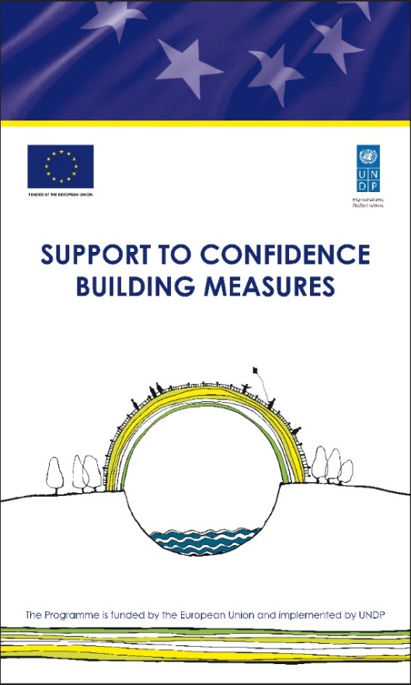
All promotional materials were updated to assure new visibility requirements of the donor – the European Union. New EU emblems with reference to `Funded by the European Union` and `This project is funded by the European Union` were placed on all promotional materials of the Programme.

SCBM on social networks promoted
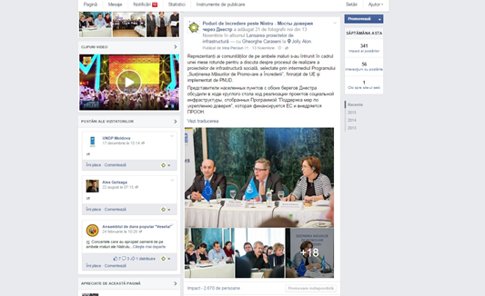
SCBM Programme uses social media as an effective and cost efficient tool to promote its achievements.

All the articles, announcements and other content were published on Facebook page of the Programme, UNDP Twitter channel, Flickr, and Instagram. During the eight months of implementation of SCBM IV, the number of followers on Facebook increased by 60 %.

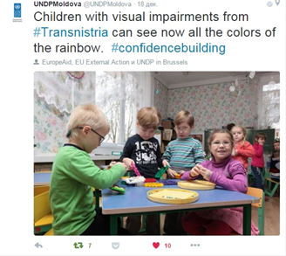
To enhance the visibility of the Programme among the people living on the left bank of the Nistru river, local communities and target groups which are less covered by Facebook and Twitter, a group on the Odnoklassniki social media website was created. It reached 630 members from August till December 2015.

The programme disseminated information towards a significantly broader audience by means of social media both in Russian and Romanian languages. The European Union contribution was mentioned in every post.

Public events conducted

During the reference period, the Programme team organized seven public events of different format which succeeded to communicate directly with large and diverse target groups: local and international mass media, general public, NGOs, business community, local authorities, national and international partners, youth. All these public events were attended by partners and beneficiaries as well as media representatives. They were widely and intensively promoted in media, on social media, UNDP, partners’ web pages. An important achievement of the Programme was the organization of the first common participation of the representatives of local communities and institutions from both sides of the Nistru River during a Round table: Increased opportunities and better living conditions across the Nistru River.

- 20 EU-funded social infrastructure projects increase confidence between both banks of Nistru River

http://jurnaltv.md/ro/news/2015/11/13/bani-din-ue-pentru-infrastructura-10171205/

http://trm.md/ro/social/ue-va-sprijini-i-anul-viitor-proiecte-de-infrastructura-sociala-in-localitatile-de-pe-malul-nistrului/

http://www.tv7.md/ro/economic/20-de-localita-i-de-pe-ambele-maluri-ale-nistrului-vor-implementa-proiecte-finan-ate-de-ue/

http://mbc.md/rom/news/economy/proiecte-de-infrastructura-finanate-de-ue/

https://www.youtube.com/watch?v=rOIZ8PXNjww&feature=youtu.be

http://moldpres.md/news/2015/11/13/15007765

http://www.ipn.md/ro/societate/72963
http://www.ipn.md/en/societate/72963
http://www.ipn.md/ru/societate/72963

http://www.infotag.md/finances-ro/212775/

http://www.radiochisinau.md/localitati_de_pe_ambele_maluri_ale_nistrului_vor_beneficia_de_bani_europeni-28216

http://moldova-suverana.md/article/circa-20-de-localitati-de-pe-ambele-maluri-ale-nistrului-vor-beneficia-de-ajutor-pentru-imbunatatirea-infrastructurii_12635

http://adevarul.ro/moldova/actualitate/ue-oferi-bani-dezvoltarea-localitatilor-ambele-maluri-nistrului-1_5645ca2a7d919ed50e2c8026/index.html

http://ziarulnational.md/noi-proiecte-finantate-de-uniunea-europeana-dezvoltate-in-20-de-localitati/

http://evzmd.md/actualitate/social/285-social/30766-ue-finanteaza-20-de-proiecte-de-infrastructura-sociala-pe-ambele-maluri-ale-nistrului.html

http://trm.md/en/social/ue-va-sprijini-i-anul-viitor-proiecte-de-infrastructura-sociala-in-localitatile-de-pe-malul-nistrului/

http://jurnal.md/ro/economic/2015/11/13/20-de-localitati-din-moldova-vor-beneficia-de-ajutor-din-partea-ue/

http://www.comunicate.md/index.php?task=articles&action=view&article_id=9092

http://tribuna.md/2015/11/13/proiecte-ale-ue-in-mai-multe-localitati-de-pe-ambele-maluri-ale-nistrului/

http://eeas.europa.eu/delegations/moldova/documents/press_corner/pr_infrastructure_project_ro.pdf

http://news.click.md/item/3-milioane-de-euro-vor-fi-investiti-in-comunitati-de-pe-ambele-m-3029ba13a0db56d10ebbbdaef0f6ebe1

http://www.politik.md/articles/social/ue-da-inca-trei-milioane-de-euro-pentru-imbunatatirea-conditiilor-in-educatie-medicina-si-cultura/34916/

http://stirimd.net/?p=5256

http://www.interlic.md/2015-11-13/ue-finan-eaza-20-de-proiecte-de-infrastructura-sociala-care-vor-spori-increderea-pe-ambele-maluri-al-41678.html

http://oficial.md/economie/ue-finanteaza-20-de-proiecte-de-infrastructura-sociala-pe-ambele-maluri-ale-nistrului
http://point.md/ru/novosti/ekonomika/20-naselennih-punktov-moldovi-poluchat-pomoschj-ot-es

http://timpromanesc.ro/3-milioane-de-euro-vor-fi-investite-in-20-de-comunitati-de-pe-ambele-maluri-ale-nistrului

http://www.acsa.md/libview.php?l=ro&idc=114&id=4324&t=/NOUTATI/Circa-20-de-localitati-de-pe-ambele-maluri-ale-Nistrului-vor-beneficia-de-ajutor-pentru-imbunatatirea-infrastructurii
http://mediacenter.md/aktualno/968-es-finansiruet-vnedrenie-20-proektov-po-uluchsheniyu-socialnoy-infrastruktury-na-oboih-beregah-dnestra.html

http://www.womenin.org/index.php/RU/glavnaya-2/9-news-a-events/153-es-finansiruet-vnedrenie-20-proektov

http://press.try.md/item.php?id=155283

http://www.beltsymd.ru/2015/11/14/economy/20-naselennyx-punktov-moldovy-poluchat-pomoshh-ot-evrosoyuza

http://www.infotag.md/m9_finances/212770/

http://www.ngo-ardt.com/news/es-finansiruet-vnedrenie-20-proektov-po-uluchsheni.html

- Young entrepreneurs from both banks of the Nistru river met at a Business Forum in Chisinau

http://trm.md/ro/economic/tinerii-antreprenori-de-pe-ambele-maluri-ale-nistrului-s-au-intrunit-in-cadrul-unui-forum-de-afaceri/

http://trm.md/en/economic/tinerii-antreprenori-de-pe-ambele-maluri-ale-nistrului-s-au-intrunit-in-cadrul-unui-forum-de-afaceri/
http://agora.md/stiri/14687/tinerii-antreprenori-de-pe-ambele-maluri-ale-nistrului-s-au-intrunit-in-cadrul-unui-forum-de-afaceri-la-chisinau

http://diez.md/2015/12/03/tinerii-antreprenori-de-pe-ambele-maluri-ale-nistrului-s-au-intrunit-la-chisinau/?utm_source=rss&utm_medium=rss&utm_campaign=tinerii-antreprenori-de-pe-ambele-maluri-ale-nistrului-s-au-intrunit-la-chisinau

http://www.ipn.md/ro/societate/73364
http://www.ipn.md/en/societate/73364

http://www.noi.md/md/news_id/74146

http://mbc.md/rom/news/economy/arena-de-discuii-pentru-tinerii-antreprenori/
http://mbc.md/rus/news/economy/arena-dlya-obsuzhdeniya-problem-biznesa/

http://agrobiznes.md/tinerii-antreprenori-de-pe-ambele-maluri-ale-nistrului-s-au-intrunit-in-cadrul-unui-forum-de-afaceri-la-chisinau.html

http://bani.md/tinerii-antreprenori-din-stanga-nistrului--pentru-prima-data-la-un-forum-de-afaceri-de-la-chisinau-au-furat-meserie-de-la-businessmeni-de-succes---66088.html

- SCBM Programme participation at EU Days in Chisinau and Soroca

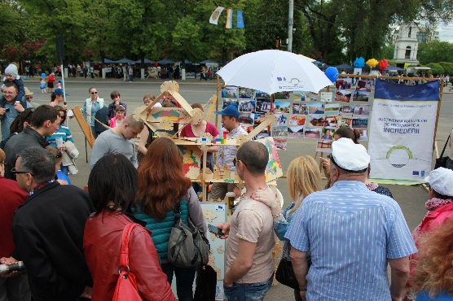
The Programme was very active in promoting confidence building messages and visibility materials during Europe Days in Chisinau and Soroca. The SCBM stand at these events was attractive for the visitors and communication team engaged in discussions with visitors on importance of confidence building, programme goals and achievements as well as the EU financial assistance, collecting feedback. The most active participants and visitors were handed out programme visibility materials (t-shirts, bags, desk-calendars, leaflets etc.).
Europe Days, Chisinau, May 2015
Facebook: https://www.facebook.com/podurideincredere/photos/pb.1428734477353667.-2207520000.1450703997./1728877190672726/?type=3&theater
https://www.facebook.com/podurideincredere/photos/pb.1428734477353667.-2207520000.1450703997./1728877204006058/?type=3&theater
Communication and visibility materials disseminated

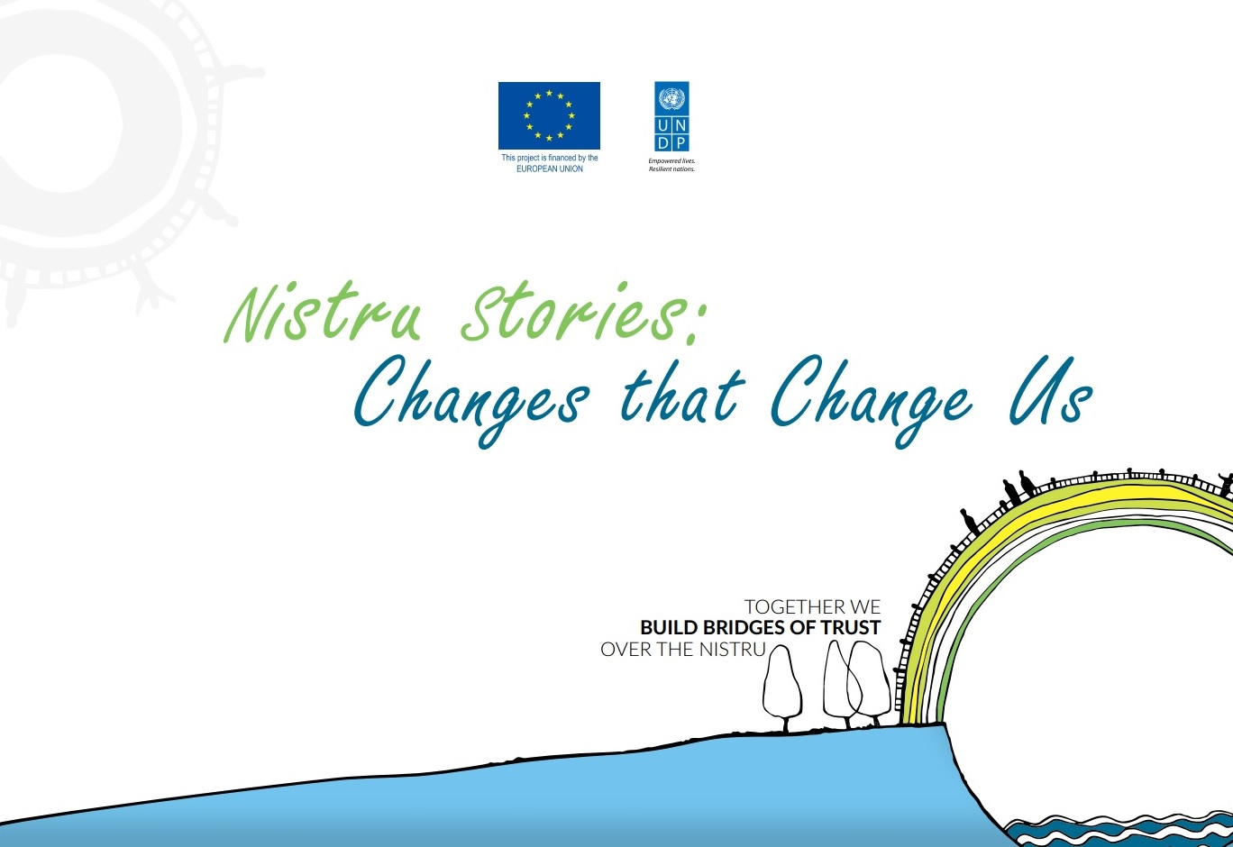
With a view to further increase the SCBM Programme’s visibility and promote the results achieved, several visibility materials have been produced and distributed, including infographic flyers, containing in addition to the basic information of the Programme the results achieved within all components in a clear and accessible way. Updated visibility materials were distributed to Programme’s partners, beneficiaries, journalists and to general public.

http://www.md.undp.org/content/dam/moldova/docs/Publications/Istorii%20Nistrene%20EN%20web.pdf
Media and public opinion regularly informed

In the mentioned period, the Programme continued to regularly inform the public at large about various activities. In total, ten press releases were produced and disseminated to national and regional media (including mass media from Transnistria region), and placed on UNDP’s web-site and social media networks. A field visit and meeting with Programme’s beneficiaries was organised for a team of journalists from the Romanian National Television who published an article about Programme’s achievements and sustainability of the projects implemented during previous phases.

http://stiri.tvr.ro/intre-doua-lumi-un-reportaj-din-republica-moldova-la-aproximativ-25-de-ani-de-la-izbucnirea-conflictului-transnistrean_68191.html

Relevant links:

- 60 children in Caragas, on the left bank of the Nistru, get access to pre-school education

http://mir24.tv/video_news/12623421/12623411

http://tv7.md/ro/social/un-bloc-al-gradinitei-din-satul-caragas-a-fost-reconstruit/

https://tv.pgtrk.ru/news/20150520/32010
http://novostipmr.ru/video/tsv/2015-05-sadik-v-sele-karagash/

http://novostipmr.com/ru/news/15-05-20/v-sele-karagash-slobodzeyskogo-rayona-posle-kapitalnogo-remonta

http://ipn.md/ro/societate/69518
http://www.infotag.md/culture-ro/203975/
http://diez.md/2015/06/23/masuri-de-sporire-a-increderii-gradinita-din-caragas-o-punte-intre-cele-doua-maluri-ale-nistrului/
http://www.infotag.md/m9_culture/203961/

http://radio.pgtrk.ru/news/200515/v-sele-karagash-slobodzeyskogo-rayona-posle-kapitalnogo-remonta-otkryt-odin-iz-korpusov

http://www.zdg.md/stiri/stiri-sociale/peste-50-de-copii-din-stanga-nistrului-au-obtinut-acces-la-educatia-prescolara

http://ziarulnational.md/circa-60-de-copii-din-stanga-nistrului-au-obtinut-acces-la-educatia-prescolara/

http://www.realitatea.md/CONDITII-MAI-BUNE-PENTRU-MICUTII-DE-LA-O-GRADINITA-DIN-STANGA-NISTRULUI--DIN-BANI-EUROPENI---FOTO_21037.HTML

http://trm.md/ro/regional/condi-ii-mai-bune-de-educa-ie-pentru-200-de-copii-din-caragas/

http://www.jurnal.md/ro/social/2015/5/21/conditii-mai-bune-de-educatie-pentru-200-de-copii-din-stanga-nistrului/
http://www.evzmd.md/actualitate/educatie/297-educatie/19991-copiii-din-stanga-nistrului-vor-beneficia-vor-de-conditii-mai-bune-de-educatie-pre%C8%99colara.html

http://www.pan.md/news/V-sele-Karagash-200-detey-poluchili-vozmojnosti-hoditi-v-detsad/55318

http://www.ziuadeazi.md/post/masuri-de-sporire-a-increderii-gradinita-din-caragas-o-punte-intre-cele-doua-maluri-de-nistru

- Producători autohtoni de pe ambele maluri participă la cea mai mare expoziție de încălțăminte și accesorii din lume

http://www.ipn.md/ro/economie-business/70925
http://www.ipn.md/ru/economie-business/70925

http://www.trm.md/ro/economic/companii-de-pe-ambele-maluri-ale-nistrului-participa-la-cea-mai-mare-expozitie-de-incaltaminte-si-accesorii-din-lume/

http://www.noi.md/ru/print/news_id/65818
http://madein.md/news/producatorul-autohton/producatorii-autohtoni-de-incaltaminte-la-expozitia-din-dusseldorf

http://www.timpul.md/articol/cinci-producatori-de-incalaminte-locali-participa-la-o-expoziie-internaionala-din-germania-77406.html?action=print

http://www.moldovenii.md/md/news/view/section/542/id/17292

http://adevarul.ro/moldova/actualitate/producatoriimoldoveni-prezenti-cea-mai-mareexpozitie-incaltaminte-lume-1_55b7465bf5eaafab2c0466ca/index.html

http://www.allmoldova.com/news/otechestvennye-proizvoditeli-uchastvuyut-v-krupnejshej-v-mire-obuvnoj-vystavke/

http://www.ngo-ardt.com/news/press-reliz-proizvoditeli-s-oboih-beregov-dnestra-.html
http://mirpmr.ru/news/economy/21849.html

http://dr-ecology.blogspot.com/2015/07/blog-post_29.html

http://mediacenter.md/obiavleniya/700-proizvoditeli-s-oboih-beregov-dnestra-prinimayut-uchastie-v-krupneyshey-v-mire-vystavke-obuvi-i-aksessuarov.html

http://www.ngo-ardt.com/news/press-reliz-proizvoditeli-s-oboih-beregov-dnestra-.html

http://www.womenin.org/index.php/RU/glavnaya-2/9-news-a-events/134-proizvoditeli-s-oboikh-beregov-dnestra-prinimayut-uchastie-v-krupnejshej-v-mire-vystavke-obuvi-i-aksessuarov
- Grant competition for business ideas

http://www.ipn.md/ro/societate/71736

http://www.moldova.org/opotunitate-pentru-tinerii-din-zona-de-securitate-granturi-europene-pentru-afaceri-si-instruiri

http://agora.md/stiri/12576/ue-ofera-granturi-pentru-afaceri-si-instruiri-pentru-tinerii-din-zona-de-securitate

http://eco.md/index.php/economie/actualitate/item/3839-granturi-pentru-afaceri-destinate-tinerilor-din-zona-de-securitate

http://www.evzmd.md/actualitate/social/285-social/27461-granturi-pentru-afaceri-destinate-tinerilor-din-zona-de-securitate.html

http://www.civic.md/grants/29729-granturi-pentru-afaceri-si-instruiri-pentru-tinerii-din-zona-de-securitate.html

http://mbc.md/rom/news/economy/granturi-pentru-tinerii-antreprenori-din-zona-de-securitate/

http://diez.md/2015/09/15/concurs-de-granturi-pentru-viitorii-tineri-afaceristi-poti-castiga-pana-la-13-500-de-euro/?utm_source=rss&utm_medium=rss&utm_campaign=concurs-de-granturi-pentru-viitorii-tineri-afaceristi-poti-castiga-pana-la-13-500-de-euro

http://trm.md/ro/regional/granturi-pentru-afaceri-si-instruiri-pentru-tinerii-din-zona-de-securitate/

http://trm.md/ru/regional/granturi-pentru-afaceri-si-instruiri-pentru-tinerii-din-zona-de-securitate/

http://www.noi.md/md/print/news_id/68674

http://point.md/ru/novosti/obschestvo/es-videlit-grant-dlya-15-molodih-biznesmenov

http://rtr.md/novosti/biznes/grant-ot-es-poluchat-15-molodyx-biznesmenov

http://mbc.md/rus/news/social/grant-ot-es-dlya-15-molodyih-biznesmenov/

http://www.allmoldova.com/news/grant-ot-es-dlya-15-molodyx-biznesmenov/

http://www.vesti.md/?mod=news&id=46873

http://infoeuropa.md/proiecte-europene/tinerii-din-zona-de-securitate-pot-beneficia-de-granturi-europene-pentru-dezvoltarea-afacerii

http://adevarul.ro/moldova/social/tinerii-moldoveni-primi-granturi-europene-afaceri-1_55f91f1ef5eaafab2ca90c38/index.html

http://moldova-suverana.md/article/granturi-pentru-afaceri-si-instruiri-pentru-tinerii-din-zona-de-securitate_11983

http://www.cuvintul.md/article/6093/

http://provincial.md/fierbinte/concurs-de-granturi-pentru-idei-de-afaceri

http://news.click.md/item/opotunitate-pentru-tinerii-din-zona-de-securitate-granturi-europ-9b4093843275792c3b837e5a2f7686be

http://www.ziarelive.ro/stiri/granturi-pentru-tinerii-antreprenori-din-zona-de-securitate.html

http://www.ziaruldeiasi.ro/stiri/tinerii-moldoveni-pot-primi-granturi-europene-pentru-afaceri--1104560.html

http://www.dubasari.md/news/concurs_de_granturi_pentru_idei_de_afaceri/2015-09-15-4328

http://www.moldovenii.md/ru/news/view/section/542/id/18108/from/noi

http://www.euractiv.ro/euractiv-moldova/UE-ofera-granturi-pentru-afaceri-tinerilor-din-Zona-de-Securitate-1465

http://agrobiznes.md/concurs-de-granturi-pentru-idei-de-afaceri.html
Press trips organised

Press trips are another very effective way to communicate the Programme’s results and partners’ joint actions to the general public. Five press trips were organized for media representatives from both banks of the Nistru River who had the opportunity to see the results and interact with beneficiaries. In addition, during press trips media representatives had the possibility to cover more than one subject, according to each media institution’s specificity.

- Relevant links: Environmental situation improves in left-bank Slobozia district thanks to the European Union

http://www.md.undp.org/content/moldova/ro/home/presscenter/pressreleases/2015/09/28/environmental-situation-improves-in-left-bank-slobozia-district-thanks-to-the-european-union/

http://www.un.md/viewnews/319/

http://www.civic.md/stiri-ong/29872-situatia-ecologica-in-raionul-slobozia-din-stanga-nistrului-s-a-imbunatatit-gratie-uniunii-europene.html

http://green.gov.md/libview.php?l=ro&idc=61&id=297&t=/Evenimente-nationale/tiri/Situatia-ecologica-in-raionul-Slobozia-din-stanga-Nistrului-s-a-imbunatatit-gratie-Uniunii-Europene

http://www.canalregional.md/index.php/economic/item/5423-serviciile-de-gestionare-a-de%C8%99eurilor-au-fost-modernizate

http://www.comunicate.md/index.php?task=articles&action=view&article_id=8968

http://www.ziarulnational.md/ue-a-mai-rezolvat-o-problema-din-r-moldova/

http://www.allmoldova.com/ro/news/romana-ue-a-mai-rezolvat-o-problema-din-r-moldova/
http://www.noi.md/md/news_id/69543

http://provincial.md/la-raion/raionul-slobozia-si-a-solutionat-una-dintre-cele-mai-stringente-probleme

http://ong.md/index.php/news/4709/15/Situa-ia-ecologica-in-raionul-Slobozia-din-stanga-Nistrului-s-a-imbunata-it-gra-ie-Uniunii-Europene/d,detalii_stire

http://mirpmr.ru/news/society/24125.html

http://mediacenter.md/thresektor/864-ekologiya-v-slobodzeyskom-rayone-na-levom-beregu-dnestra-uluchshilas-blagodarya-evropeyskomu-soyuzu.html

http://www.womenin.org/index.php/RU/glavnaya-2/9-news-a-events/137-28-09-2015

http://dr-ecology.blogspot.md/2015/09/blog-post_29.html?view=timeslide

http://apriori-center.org/news/1059

http://vestipmr.info/articles/2015/09/28/v-slobodzee-rabotaet-novaya-spectehnika-dlya-uborki-i-vyvoza

http://www.ngo-ardt.com/news/ekologiya-v-slobodzeyskom-rayone-uluchshilas-blago.html

http://novostipmr.ru/info/vesti/2015-09-v-slobodzee-rabotaet-novaya-spectexnika-dlya-uborki-i-vyvoza-musora/

http://www.europalibera.org/media/video/moldova-photo-video/27277587.html?z=16956&zp=1

https://www.youtube.com/watch?v=KkhMckbrB94&feature=youtu.be

http://zerkalo.tv/%D0%B2-%D1%81%D0%BB%D0%BE%D0%B1%D0%BE%D0%B4%D0%B7%D0%B5%D0%B5-%D1%81%D1%82%D0%B0%D0%BB%D0%BE-%D1%87%D0%B8%D1%89%D0%B5/

http://karavan.md/article/573

http://mirpmr.ru/news/society/24299.html

http://mediacenter.md/publikacii/879-evro-grant-pomog-likvidirovat-stihiynye-svalki.html

http://dr-ecology.blogspot.md/2015/10/blog-post.html

http://www.womenin.org/index.php/RU/glavnaya-2/9-news-a-events/139-2-10-2015
Participation in the campaign Moldova in line with Europe

SCBM Programme had an active participation in the EU Delegation media awareness campaign Moldova in line with Europe. At least twenty two success stories (more than most other projects) with an emphasis on human stories were published in media, including media from the left bank.

- http://www.allmoldova.com/author_post/molodaya-mama-sozdala-semejnyj-biznes-v-moldavskom-sele/
- http://www.allmoldova.com/author_post/moldavskii-fermer-primeneaet-unikalinuiu-sistemu-oroshenia/
- http://www.allmoldova.com/article/ulichnoe-osveshhenie-po-evropejskim-standartam-a-ne-kakie-to-koptilki/
- http://www.allmoldova.com/author_post/znamenitye-cherri-uzhe-vyrashhivayut-v-moldove/
- http://www.allmoldova.com/author_post/biznesmen-iz-tiraspolya-razvernul-proizvodstvo-s-pomoshhyu-evro-granta/
- http://www.allmoldova.com/author_post/cherez-pyat-let-hai-la-tara-prevratitsya-v-mezhdunarodnuyu-set/
- http://diez.md/2015/07/24/alex-gutsaga-despre-proiectul-hai-la-tara-la-noi-strainii-s-au-simtit-oaspeti-nu-turisti/
- http://www.kp.md/daily/26472/3342100/
- http://www.kp.md/daily/26463.4/3333435/
- http://www.kp.md/daily/26452.4/3321732/
- http://www.kp.md/daily/26454/3324916/
- http://www.kp.md/daily/26466/3336367/
- http://www.kp.md/daily/26446/3316715/
- http://www.kp.md/daily/26443.4/3313448/
- http://www.kp.md/daily/26413/3287445/
- http://diez.md/2015/12/14/foto-europa-pentru-moldova-scoala-sportiva-din-criuleni-prima-institutie-de-profil-de-pe-malul-nistrului-reparata-pe-bani-europeni/
- http://diez.md/2015/09/04/moldova-in-pas-cu-europa-gradinita-din-slobozia-dusca-si-a-deschis-usile-pentru-inca-40-de-copii-datorita-investitiilor-europene/
- http://diez.md/2015/12/18/europa-pentru-moldova-europenii-au-investit-21-milioane-de-lei-intr-o-piata-agricola-moderna-construita-in-zona-de-securitate/
- http://diez.md/2015/12/09/europa-pentru-moldova-edujoc-primul-atelier-din-moldova-unde-se-produc-jucarii-ecologice-si-educative-pentru-copii-si-adulti/
- http://diez.md/2015/12/04/europa-pentru-moldova-povestea-unei-tinere-care-la-22-de-ani-a-initiat-propria-afacere-oferind-15-locuri-de-munca/
- Realitatea TV at least two articles
- On article in the paper version of Logos Press

http://www.allmoldova.com/ro/article/evropa-dlya-moldovy-samye-yarkie-istorii-uspexa-2015-goda/

Articles realised within the Moldova in line with Europe and published in media from the left bank:

http://mirpmr.ru/problemy-lyudej-s-ogranichennymi-vozmozhnostyami-v-moldove-vazhno-nauchitsya-byt-kak-vse/

http://mediacenter.md/thresektor/971-problemy-lyudey-s-ogranichennymi-vozmozhnostyami-v-moldove-vazhno-nauchitsya-byt-kak-vse.html

http://www.womenin.org/index.php/RU/glavnaya-2/9-news-a-events/155-vazhno-nauchitsya-byt-kak-vse
http://dr-ecology.blogspot.md/2015/11/blog-post_30.html?view=flipcard
http://apriori-center.org/news/1185
http://mirpmr.ru/istoriya-odnogo-biznesa-ili-kak-evropejskij-grant-podderzhal-proizvodstvo-mebeli-v-tiraspole/
http://mediacenter.md/publikacii/966-istoriya-odnogo-biznesa-ili-kak-evropeyskiy-grant-podderzhal-proizvodstvo-mebeli-v-tiraspole.html
http://www.womenin.org/index.php/RU/glavnaya-2/9-news-a-events/150-9-11-2015

http://dr-ecology.blogspot.md/2015/11/blog-post.html?view=flipcard

http://ngointeraction.org/main/en/component/content/article/1-latest-news/2987-the-history-of-the-business-or-how

http://mediacenter.md/publikacii/957-kak-evrogrant-pomog-molodoy-zhitelnice-pridnestrovya-stat-predprinimatelem.html

http://mirpmr.ru/problemy-lyudej-s-ogranichennymi-vozmozhnostyami-v-moldove-vazhno-nauchitsya-byt-kak-vse/

http://mediacenter.md/thresektor/971-problemy-lyudey-s-ogranichennymi-vozmozhnostyami-v-moldove-vazhno-nauchitsya-byt-kak-vse.html

http://www.womenin.org/index.php/RU/glavnaya-2/9-news-a-events/155-vazhno-nauchitsya-byt-kak-vse

http://dr-ecology.blogspot.md/2015/11/blog-post_30.html?view=flipcard

http://apriori-center.org/news/1185

http://mirpmr.ru/evropa-predostavila-pomoshh-nepolnym-semyam-v-pridnestrove/

http://mediacenter.md/thresektor/975-evropa-predostavila-pomosch-nepolnym-semyam-v-pridnestrove.html

http://ngointeraction.org/main/en/component/content/article/1-latest-news/3029-2015-12-07-14-16-35

http://www.ngo-ardt.com/news/evropa-predostavila-pomosch-nepolnym-semyam-v-prid.html
http://dr-ecology.blogspot.md/2015/12/blog-post.html?view=flipcard

http://apriori-center.org/news/1214

http://ngointeraction.org/main/en/component/content/article/1-latest-news/3029-europe-provided-assistance-to

http://europa-moldova.md/pentru-o-economie-mai-buna/renumitul-soi-de-roii-cherry-acum-este-crescut-i-in-moldova

http://www.womenin.org/index.php/RU/glavnaya-2/9-news-a-events/141-23-1-10-2015
Web page dedicated to young entrepreneurs developed

The webpage www.business-bridges.md is currently developed with the support of the EU and UNDP within the SCBM Programme aimed at facilitating communication and exchange of experience between young entrepreneurs from both banks of the Nistru River.

Contract number: ENPI/2014/354-587, Annex I, Description of the Action, Support to Confidence Building Measures
Regional Economic Review. Transnistrian economy at the crossroads? 12/10/2015 Expert-Grup http://www.expert-grup.org/en/biblioteca/item/119
Ibidem
Key achievements and results measured in accordance with the agreed performance indicators are presented in detail in Annex 1, along with operational targets for 2015-2017

